|  |  |
| --- | --- |
|  | **NeoMote**  **Getting Started:**  **First Projects**  **www.metronomesystems.com** |

## About This Guide

This guide describes the basic functionality of the *NeoMote*. We will also cover a basic set of tutorials to help your transition quickly into writing your own wireless embedded applications. This document is organized as a simple step-by-step process for learning the basics of using a NeoMote platform. By working through each tutorial, you will develop the basic skills and understanding to develop wireless systems of your own.

Table of Contents

About This Guide 1

Related Documents 3

Chapter 1: Preparations 5

Introduction to the NeoMote 5

Prerequisite Checklist 5

Software Setup 6

Hardware Setup 7

Chapter 2: The Tutorials 14

How to Read These Tutorials 14

Getting Started 15

Tutorial 1: Blinking an LED 15

Introduction 15

Starting a New Project 16

Adding Components 17

Assigning Pins 18

Writing Code 19

A Quick Note on Debugging 21

More Efficient Implementation of the BlinkLED Code (optional) 23

Tutorial 2: Communicating Using the USB Port 23

Introduction 24

Creating a New Project 24

Adding Components 24

Assigning Pins 25

Clock Settings 25

Building the Project 26

Adding Code 26

Code Explanation 27

Building and Running the Code 27

One Time Installation of USB Drivers 28

Testing the Firmware 29

Tutorial 3: Reading from an Analog Sensor 31

Introduction 31

Analog to Digital Converters on the NeoMote 31

Creating a Duplicate Project 32

Adding Components 32

Assigning Pins 35

Adding Code 36

Code Explanation 38

Running the Code 39

Tutorial 4: Reading from a Digital Sensor 41

Introduction 41

Creating a Project 42

Assigning Pins 44

Adding Code 44

Code Explanation 45

Running the Code 46

Tutorial 5: Using Timers and the Real Time Clock 47

Introduction 47

Creating a Project with New Build Settings 47

Assigning Pins 51

Adding Code 51

Code Explanation 53

Running the Code 54

Tutorial 6: Writing Data to the SD Card 54

Introduction 54

Adding the emFile Libraries 55

Adding the SD (emFile) Card Component 56

Assigning Pins 57

Adding Code 57

Running the Code 59

Tutorial 7: Sending Wireless Data 59

Introduction 60

Creating a Project 60

Adding Code 60

Running the Code 61

Tutorial 8: Low-Power Mode 61

Introduction 62

Creating a Project 62

Adding Code 63

Running the Code 67

Tutorial 9: Wireless Datalogger 67

Introduction 67

Creating a Project 67

Adding Code 67

Running the Code 67

Chapter 3: Problem Solving 67

Troubleshooting Failed Compiles 68

## Related Documents

* NeoMote Datasheet
* NeoMote API reference and *PSoC Creator* datasheet
* AN-1 Adjusting Power Supply Levels
* AN-2 Low-Power Low-Noise Sensing
* AN-3 Setting up a NeoMote SmartMesh IP Network
* AN-4 Battery Voltage Reading
* SmartMesh IP Easy Start Guide
* PSoC5LP Datasheet

# Chapter 1: Preparations

## Introduction to the NeoMote

Metronome Systems provides low power, highly reliable, true systems-level solutions for a broad suite of real-time sensing and control applications. The *NeoMote* sets a new standard for ultra-configurable, ultra-low power wireless mesh networks. The *NeoMote’s* advanced design incorporates a highly-configurable, programmable system-on-chip (32-bit ARM® Cortex-M3 microprocessor unit, memory, full analog and digital peripheral) with industry-leading, ultra reliable, *IPv6*-based, low-power true-mesh wireless sensor network (WSN) technology. A unique array of configurable analog system blocks features modern methods of signal conditioning, acquisition, and processing to enable monitoring and control with high accuracy, high bandwidth, and high flexibility. Rapid prototyping and near-limitless system configurability permit users to deploy reliable and scalable wireless embedded products that support network management and comprehensive security. The system has the ability to dynamically configure up to 60 GPIOs with interfaces such as USB, SPI, UART and I2C. Innovative IEEE802.15.4-compliant radio design by *Dust Networks (Linear Technology)*enables multi-year battery life on a pair of AA batteries.

The two core components on the NeoMote are:

1. The ultra-configurable system on chip ([PSoC5LP](http://www.cypress.com/?id=4562) by Cypress)
2. The low power wireless mesh module ([SmartMesh IP](http://www.linear.com/products/SmartMesh_IP) by Linear Technology)

These components have been interfaced together by Metronome Systems to provide a development platform for customizable wireless sensor networks. What follows is a set of tutorials explaining basic development using the Metronome NeoMote system. The tutorials presented in this document are by no means exhaustive, however they will provide you with the basic tools necessary to begin writing your own NeoMote applications.

While the NeoMote is comprised of a number of system components, your primary emphasis as an embedded programmer will be the development of firmware for the *PSoC5* processor on the NeoMote. This will permit you to take readings from sensors, transmit wireless data and carry out any local control operations. The PSoC5LP processor is programmed using Cypress’ *PSoC Creator* software. Once you begin transmitting wireless data using many NeoMotes, you will likely collect and process it at some centralized location through a base station manager. This data collection will be conducted through the Linear (Dust Networks) *SmartMesh SDK*. Please follow the steps below to install the required software for the tutorials within this document.

## Prerequisite Checklist

* *Metronome Software Kit*
* Metronome NeoMote Libraries
* Cypress MiniProg3 Installer
* *External Software*
* Cypress PSoC Creator
* Linear Technology SmartMesh SDK
* Python 2.7
* PySerial 2.6
* Putty
* *Metronome Hardware Kit*
* NeoMote
* Cypress MiniProg3
* Environmental Sensing Breakout Board
* MaxBotix MB7364 or MB7384 ultrasonic sensor
* Sensirion SHT25 Temperature and Relative Humidity Sensor
* SD Card
* SmartMesh IP Manager
* Mini USB Cable
* External Hardware
* MS Windows Computer with two available USB ports
* Small Philips-head Screwdriver

## Software Setup

The software used for these tutorials will require several steps for installation. This section will go through such steps in order to prepare for the tutorials. The Metronome Software kit provides all the necessary software, but alternate methods for acquiring each will be provided.

### Metronome NeoMote Libraries

**Note:** Available exclusively from Metronome Systems.

The NeoMote libraries do not have any conventional installer. They will instead be included in the tutorials using the PSoC Creator as we progress.

### Cypress PSoC Creator

**Note:** Available for download from [Cypress](http://www.cypress.com/psoccreator/). Requires making a Cypress account. Requires you to download their installer.

Install the latest PSoC Creator using **PSoCCreatorSetup_3.0.exe** available form Cypress**.** Use the typical install options, there is no need to change any settings. There is no need to enter your information or register. When you run PSoC Creator the first time, you can check the box to stop it from asking you to register on startup. There is also no need to update.

### Cypress MiniProg3 Installer

**Note:** Available on the install cd included with the MiniProg3 itself.

Using the Cypress website or the CD provided with the MiniProg3, install the programmer. Follow the typical install path. After the install, remove the tape and plug in your MiniProg3 to the USB port with the included cable. The MiniProg will be recognized, completing the installation. Further instructions are available in the **Hardware** section below.

### Putty

**Note:** Available for download from [Putty.org](http://www.chiark.greenend.org.uk/~sgtatham/putty/download.html). **Note also:** Putty is by no means the only Serial Terminal client. If you have one already or prefer another you are welcome to use it. For the purposes of the tutorial, examples will be demonstrated using Putty. We also really like RealTerm.

Putty requires no additional installation beyond simply downloading it. It can be run using the **putty.exe** file.

### Linear Technology SmartMesh SDK

**Note:** Available for download from [Linear Technology](http://www.linear.com/designtools/software/#Dust).

The SDK also requires no installation beyond the unzipping of the folder in the case you needed to download it. The use of the SDK is described in AN-3 and Linear’s SmartMesh_IP_Easy_Start_Guide. This software is only required for the last portions of the tutorial.

### Python 2.7

**Note:** Available for download from [python.org](http://www.python.org/getit/).

**Note:** If you already have Python 2.7 or 3.2 installed you may skip this step.

Install Python 2.7 using the installer **python-2.7.5.msi**. Install to C:\Program Files.

### PySerial 2.6

**Note:** Available for download from [pypi.python.org](https://pypi.python.org/pypi/pyserial). It will require using a program to unzip the folder once downloaded.

Install PySerial 2.6 using the **setup.py** file in the **pyserial-2.6** folder.

* Using the Command Prompt, navigate to the pyserial-2.6 folder.
* Use the command **python setup.py install**.

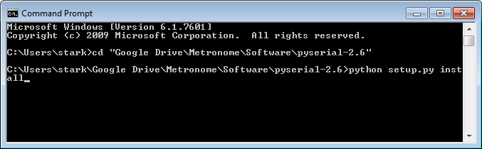

## Hardware Setup

After having installed the aforementioned software on your Windows PC you will need to set up the hardware.

### NeoMote

The NeoMote is the core component of the Metronome kit. In order to use it for this tutoprial, we will simply have to set the jumpers correctly and plug it into the computer. Please see our documentation on the various power modes of the NeoMote to see what’s right for your application.

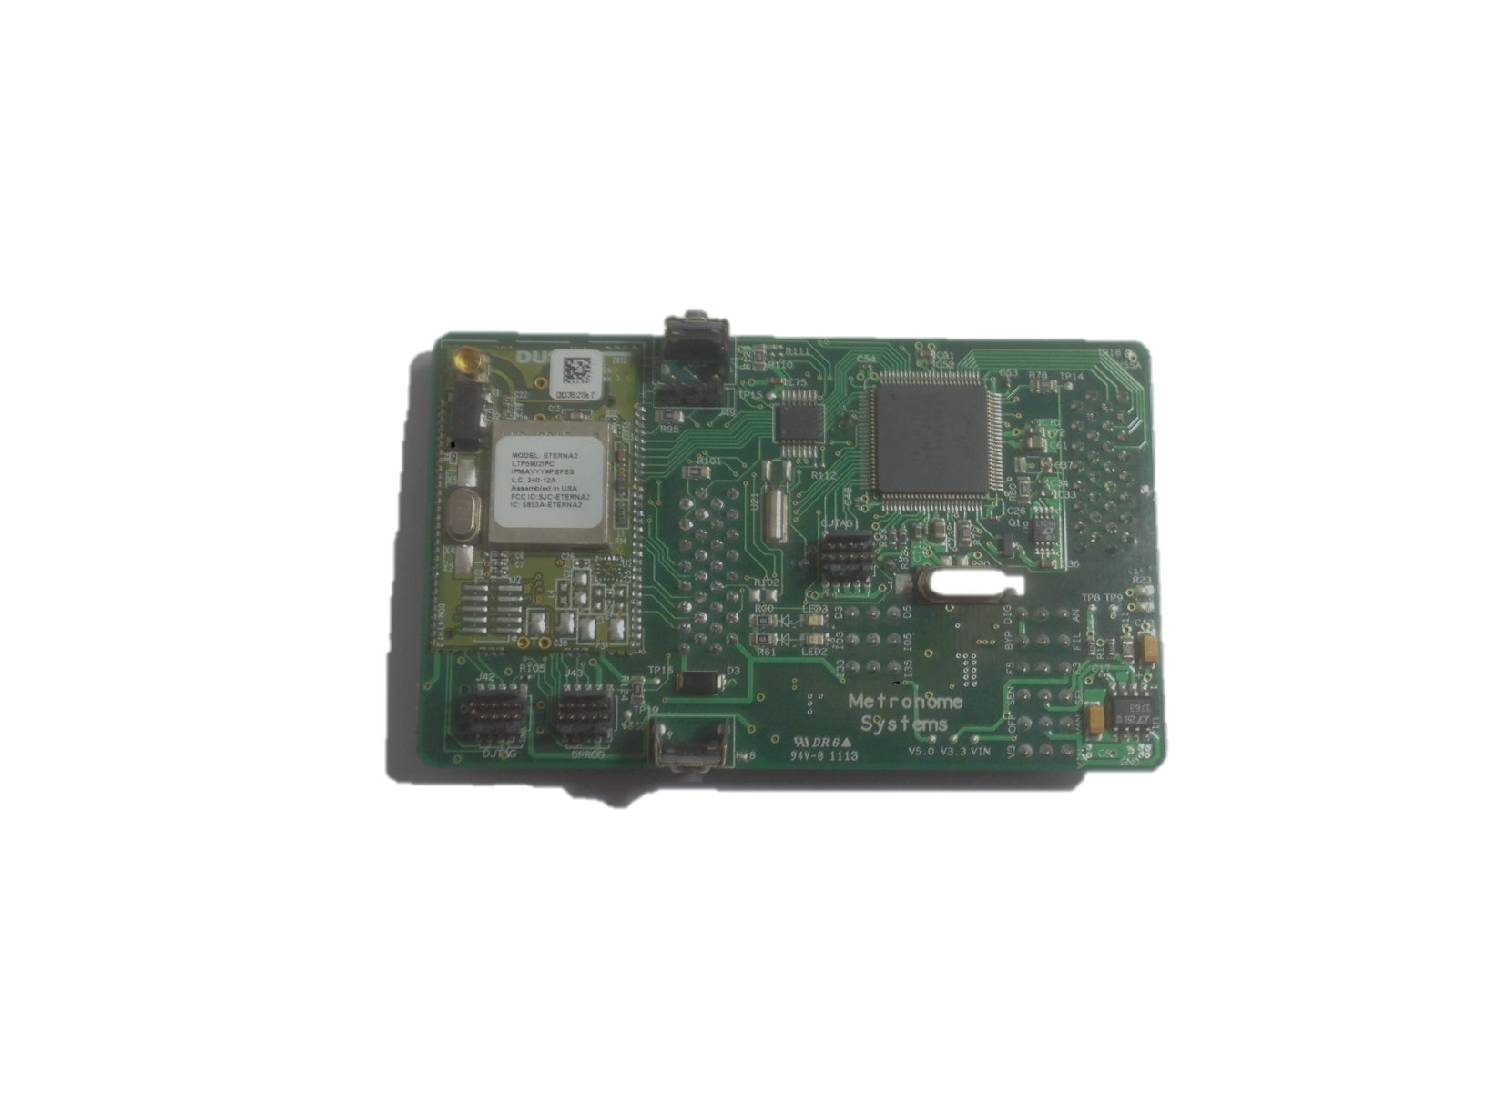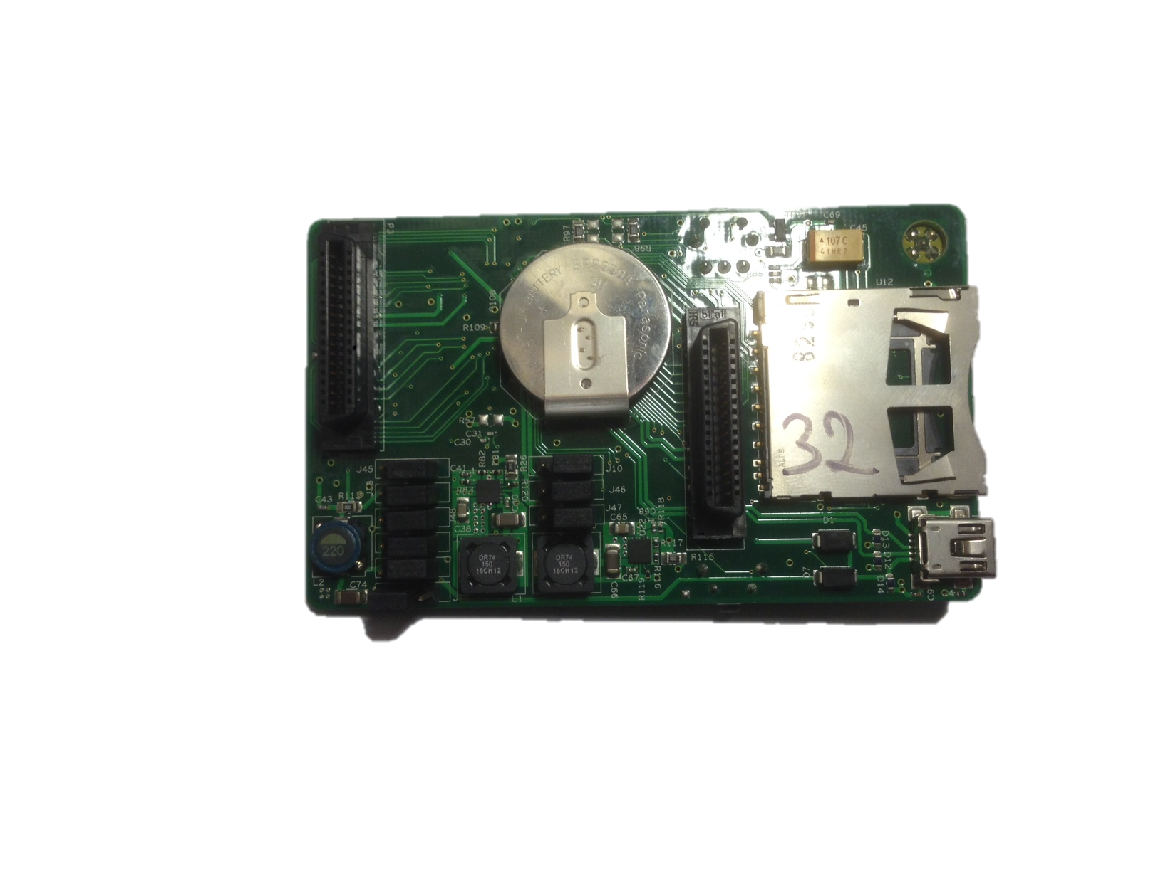

Jumpers

J6

J5

J4

J3

J2

J1

1 2 3

J9

J8

J7

1 2 3

* Put jumpers J1 and J9 in position 1-2 as depicted in the picture above.
* Put the rest, J2-J8, in position 2-3 as depicted.

**Note:** Setting these jumpers correctly is important for the tutorials. See AN-1 Adjusting Power Supply Levels for more detailed explanations of the function of each of these jumpers.

To connect the NeoMote to your computer, you will need to use a MiniUSB cable.

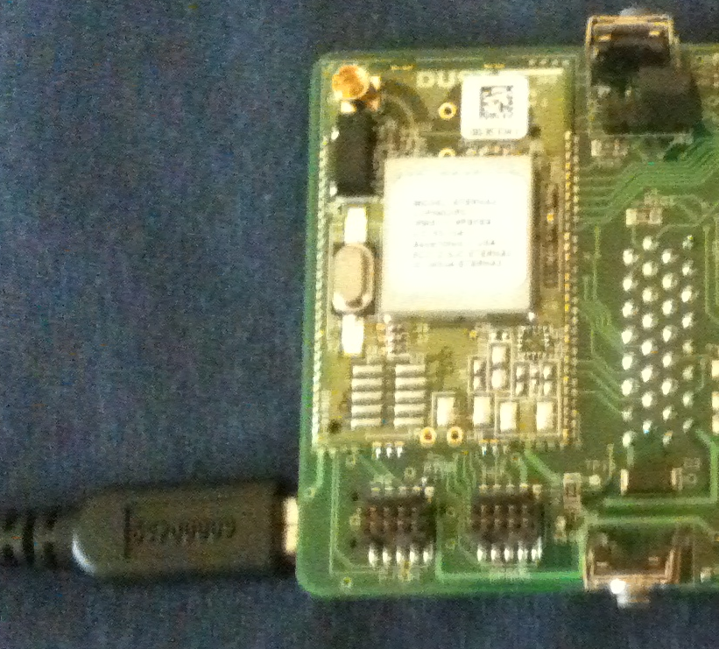

### Cypress MiniProg3

The MiniProg3 is the device that will allow us to interface between the PSoC Creator program and our NeoMote. It interprets and translates to allow for easy programming of the Cypress board that is part of the NeoMote.

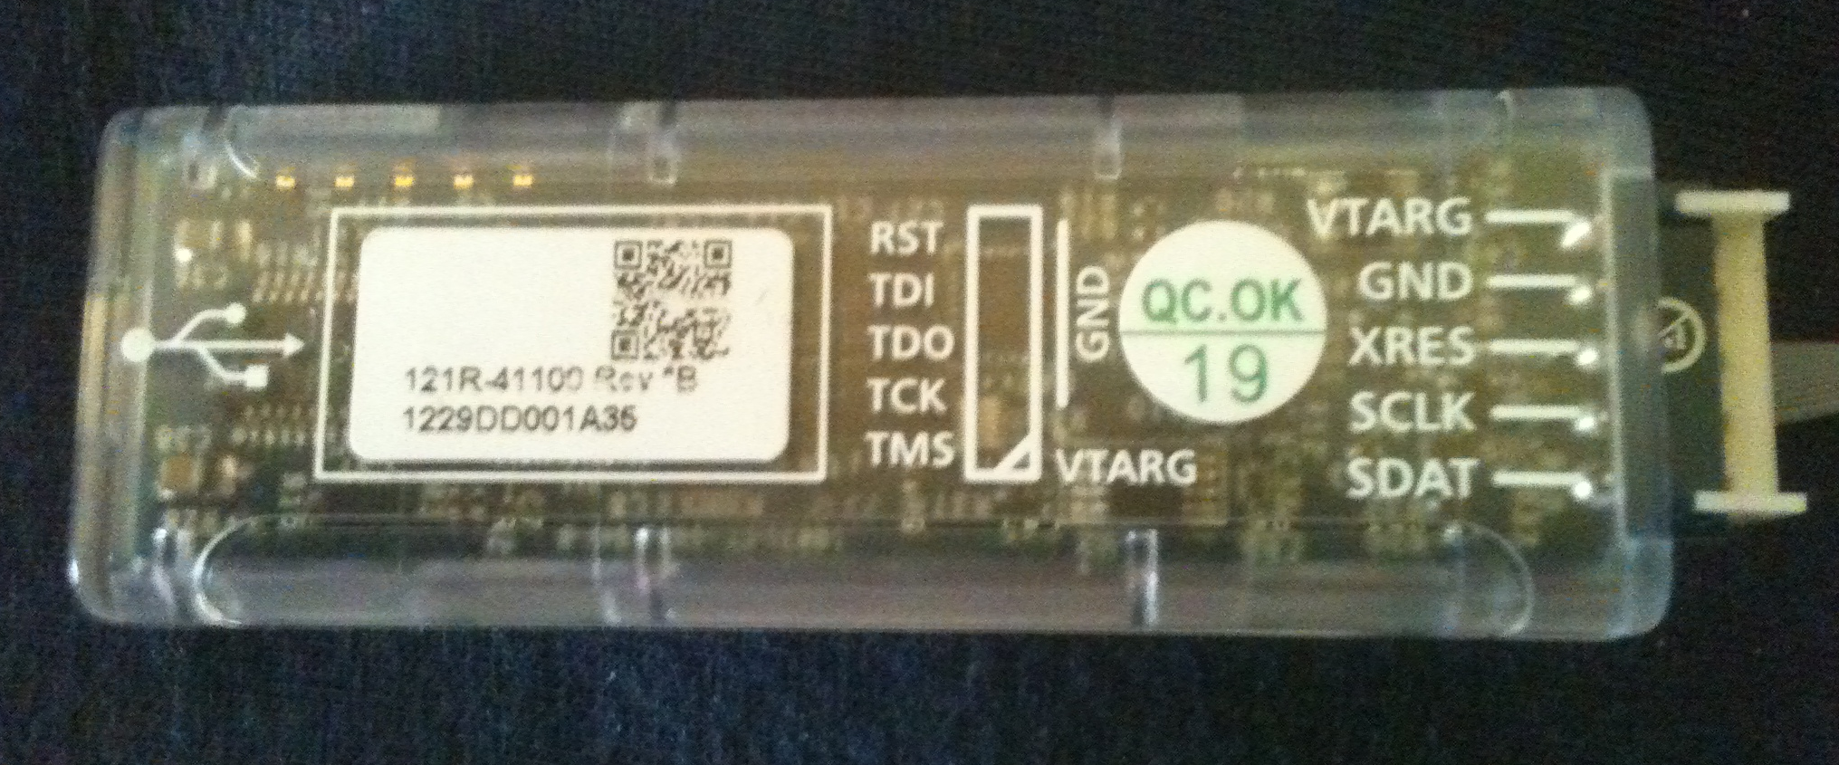

**Note:** Before plugging in the MiniProg3, make sure you have completed the MiniProg software installation step.

* After the software install, plug in your MiniProg3 to the USB port of your computer with the included MiniUSB cable.

The MiniProg will be recognized, completing its installation. Now it is ready to connect to the NeoMote.

* Remove the tape tab on the MiniProg and use the 10-pin ribbon cable to connect it to the 10-pin interface on the NeoMote as depicted below.

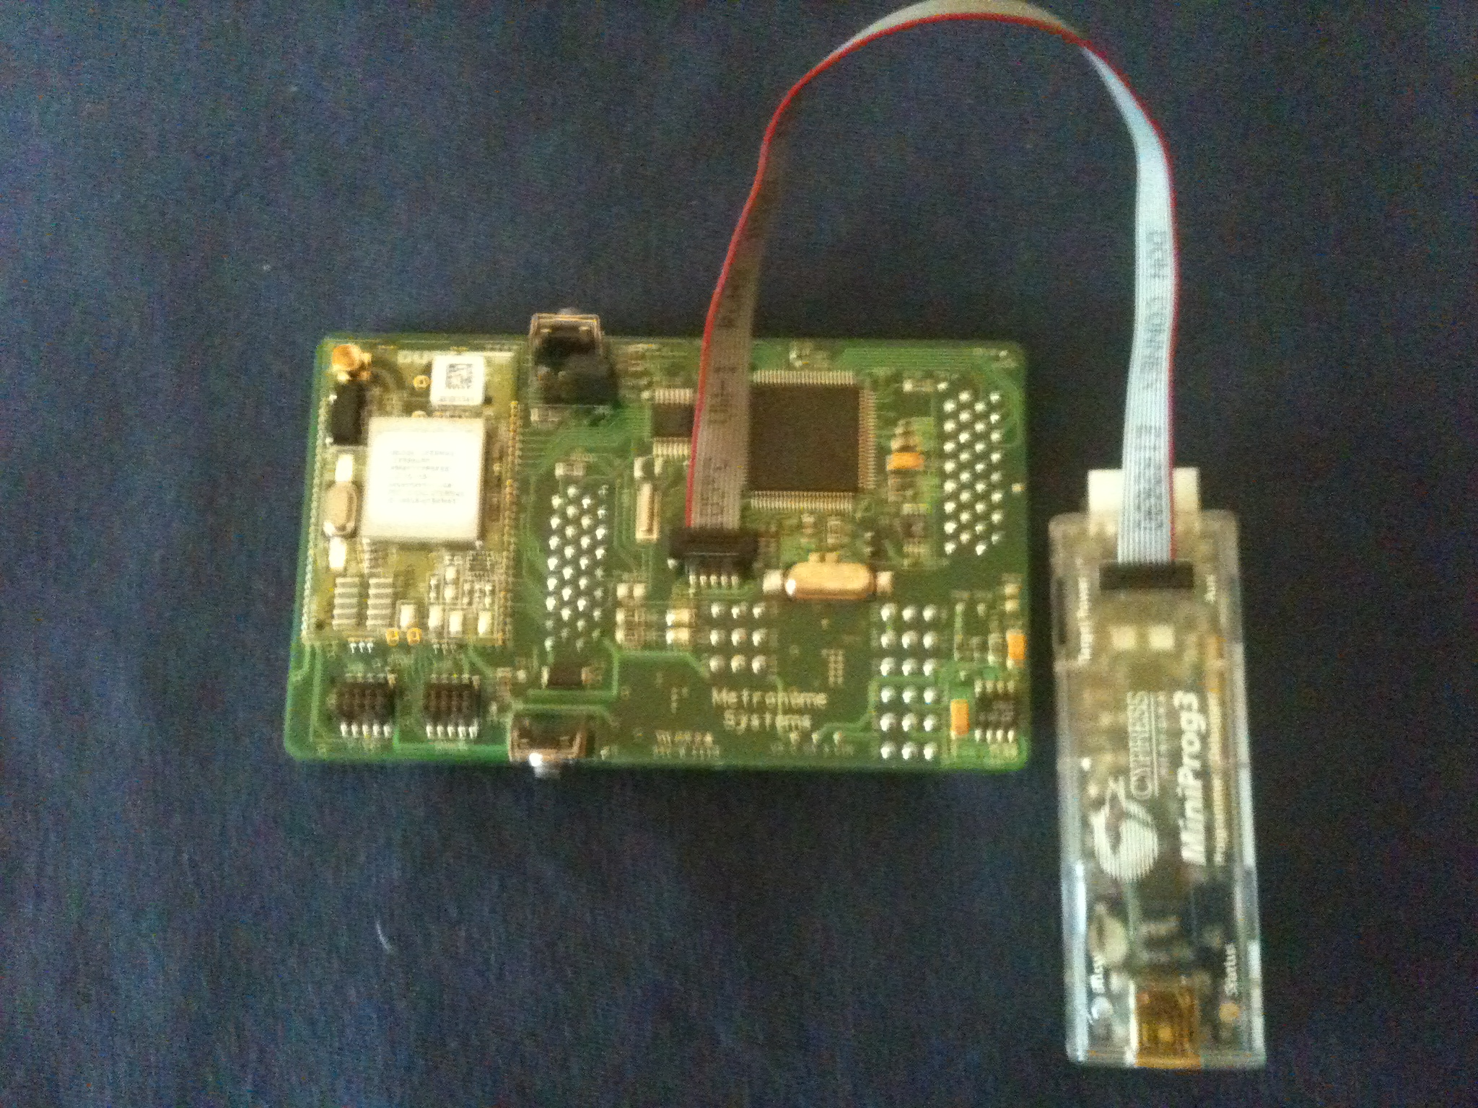

**Note:** For more information about the use and capabilities of the MiniProg3, see its datasheet: **CY8CKIT MiniProg3 Guide.pdf**

### Environmental Breakout Board

The EnvBoard provides an easy interface between the NeoMote and whichever sensors you choose to attach. It was designed for environmental sensor applications, but you can use it for just about anything else also. It allows for direct connection to a variety of useful NeoMote input/output pins.

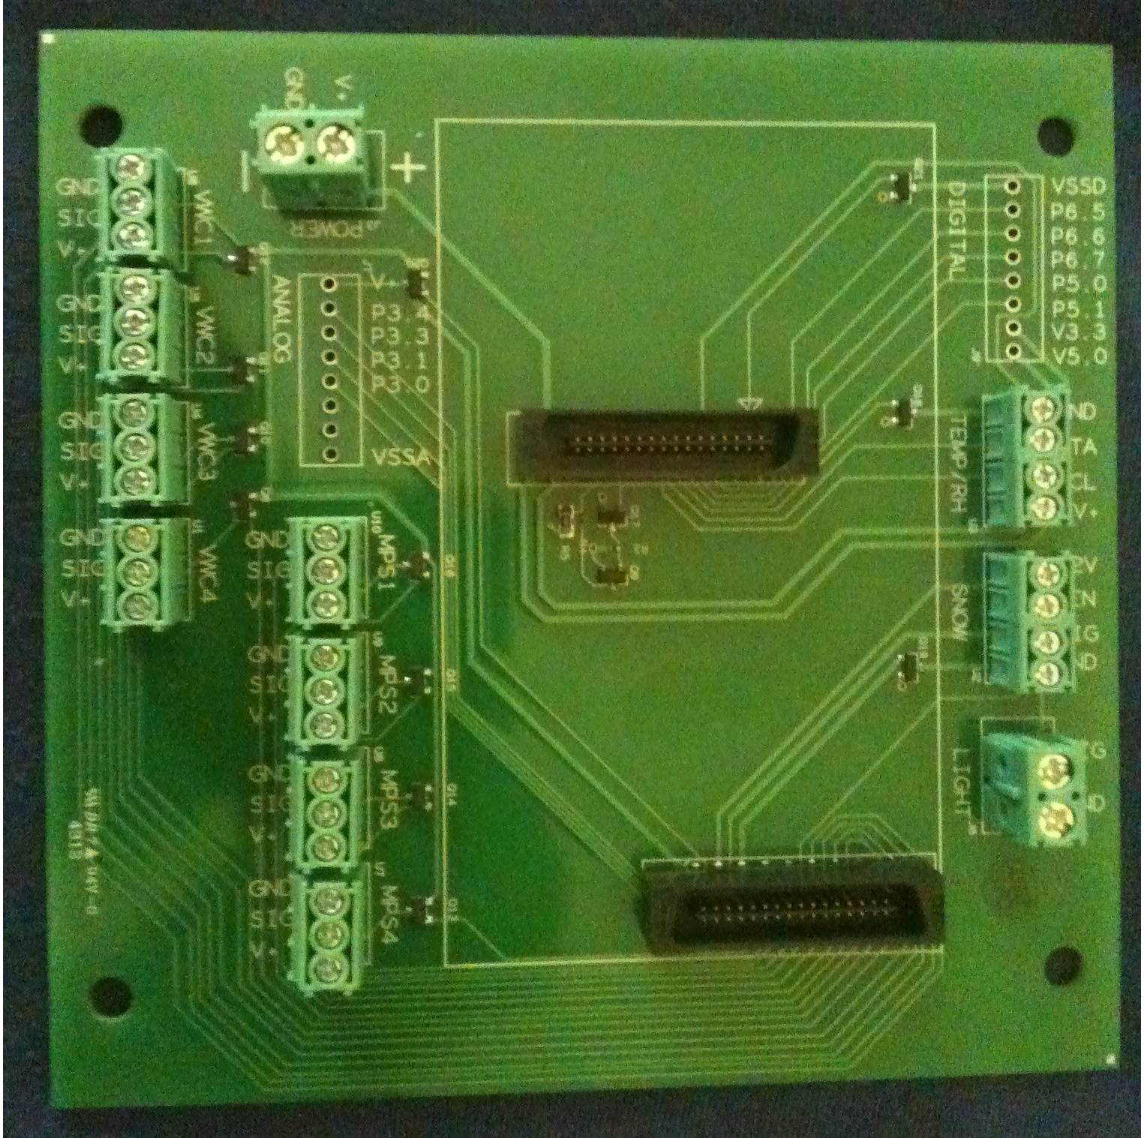 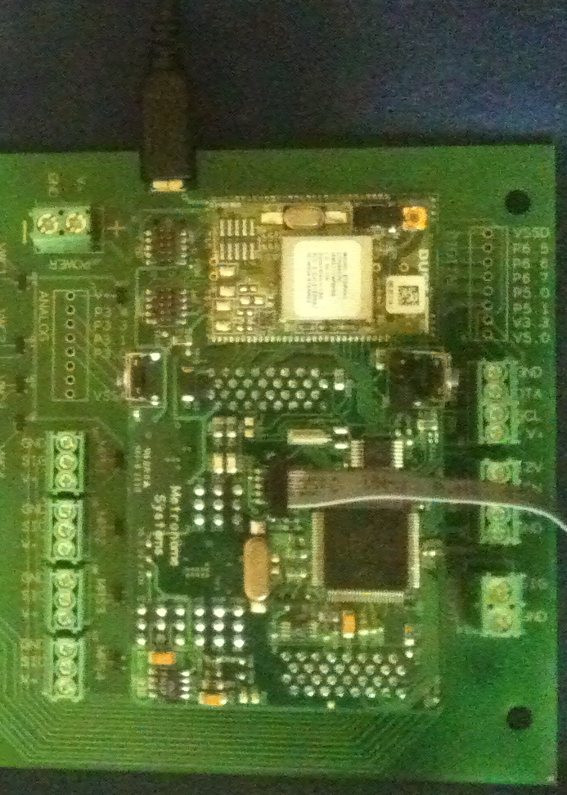

Connecting to the EnvBoard is as simple as plugging the NeoMote into the designated area.

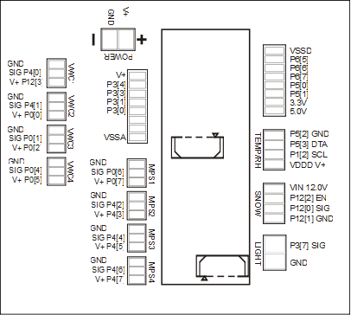

This Pin-out schematic describes the different I/O pins which the breakout board interfaces to. The next two sections will discuss connecting the ultrasonic distance sensor to the VWC1 port and the Temperature/RH sensor to the Temp/RH port on the board.

### SD Card

In these tutorials we will demonstrate how to write to an SD card as a convenient local storage solution. The SD card setup physically requires only to be formatted and plugged into the NeoMote. The firmware will all be explained in the tutorial that covers the setup and use of the card.

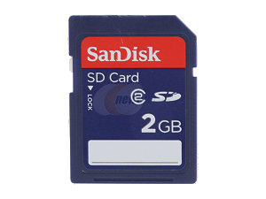

To format the SD Card, put it into a computer with an SD Card reader. This should open a dialog asking if you would like to format it, which you would.

**Note:** If your SD Card is already formatted with a FAT file system, you can skip this step entirely. If you don’t have access to an SD Card reader, find an SD Card that has already been formatted or ask someone else to format it for you.

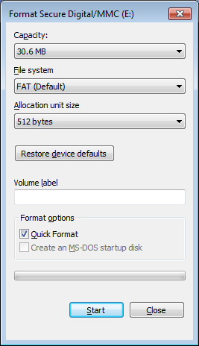

The default settings are usually acceptable as long as the file system is set to **FAT** (File Allocation Table) the tutorial should work with it. Unless you have specific requirements for the card you will be using, just go with the suggested settings.

**Note:** If your SD Card is already formatted, it may be worth checking to see if it has a FAT file system. Most cards do, but if not the tutorial will not communicate correctly with it.

### Network Manager

The Manager’s role is to control and conduct a wireless network with the NeoMotes. We will use it to allow wireless communication between the NeoMote and the computer. It also allows for wireless programing and adjustment of settings on the motes.

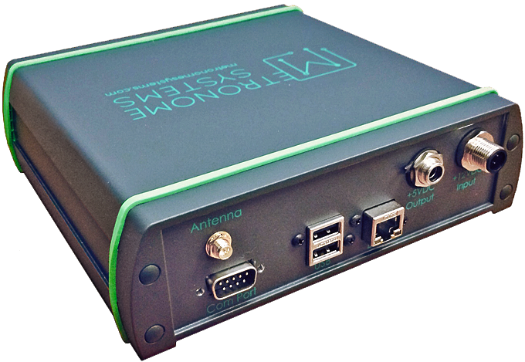

The use of the manager is as simple as connecting it to your computer via Serial or Ethernet. The manager can also be connected via the Ethernet port to your home router, cellular modem, or other network devices. It can then be accessed remotely via SSH, FTP, or a web interface. More on this later.

# Chapter 2: The Tutorials

## How to Read These Tutorials

Each of the following tutorials will lead you through the steps to develop a functional wireless data logging system. The tutorials are divided into several segments such as Creating the Project, Adding Components, Assigning Pins, Writing Code and Code Explanations. The beginning of each tutorial lists the new requirements for that segment and the general goal of that tutorial.

Code segments will be provided in text boxes in Courier New font.

Screenshots in the tutorials will have red boxes to highlight important details.

* **Bolded terms** are key points of the instructions.

**Notes:** These notes provide key details that can help avoid common mistakes and offer details for further reading.

## Getting Started

Before getting started with the tutorials, make sure you have followed all the installation steps above and have your NeoMote setup. We will start with a simple tutorial to blink LED’s and finish with a fully functional wireless network data logger.

**Note:** While the completed tutorials are available in the zip file attached to this introductory document, new users are strongly encouraged to carry out each of the tutorials on a step-by-step basis.

# Tutorial 1: Blinking an LED

## Introduction

While this is perhaps one of the most ubiquitous types of tutorial, blinking the LEDs (light emitting diodes) will introduce you to the core development tool chains of the NeoMote. The NeoMote has two LEDs, one blue and one yellow, each of which can be turned on and off by triggering two digital pins on the board. Blinking these LEDs will provide you with the basic foundation necessary for building future projects. Blinking LEDs can also be used in your future projects to provide user feedback and debugging features.

**Requirements:** *Hardware* – Computer, NeoMote, MiniProg3, Cables *Software* – PSoC Creator, MiniProg3

## Starting a New Project

Begin by opening **PSoC Creator**. When you first open PSoC Creator, you are taken to the Start Page. The Start Page shows recent projects, application notes, and design templates. Begin by creating a new blank project.

* Click on **File -> New -> Project** to open the dialog box for a new project.
* Verify that the Design tab is selected and that the **Empty PSoC5LP Design** option is highlighted.
* Change the name of the project to **BlinkLED** and chose the desired location.
* Open the Advanced tab at the bottom. You will see that it defaults to creating a workspace with the same name. This workspace (a collection of projects) will contain each tutorial you create so rename it **Tutorials**.

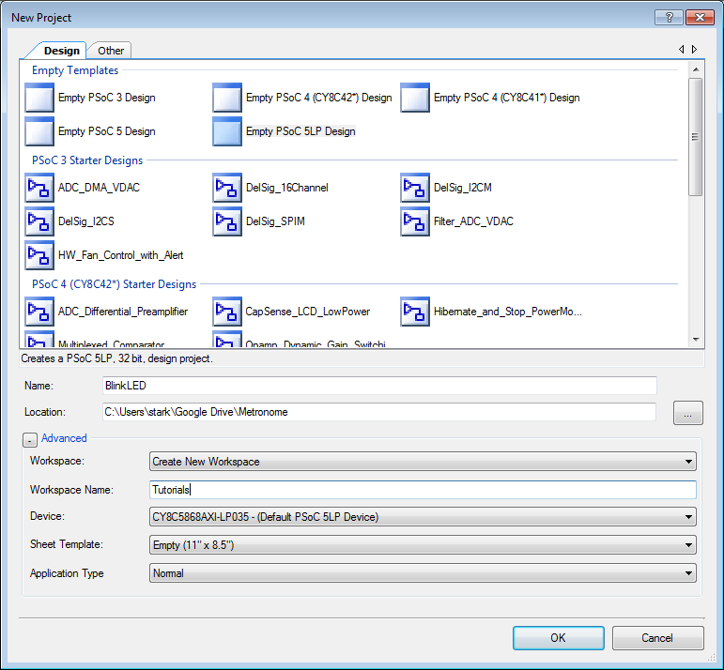

PSoC Creator generates the associated directories and files needed for your project and opens into schematic view. Schematic view gives the overall picture of the components you have selected for your project and shows how they are connected to other components. You should see Workspace Explorer to the left of your schematic, the Component Catalog to the right of your schematic, and the Output window below your schematic. If you do not see all three of these windows, click the View menu and choose the missing window from the menu.

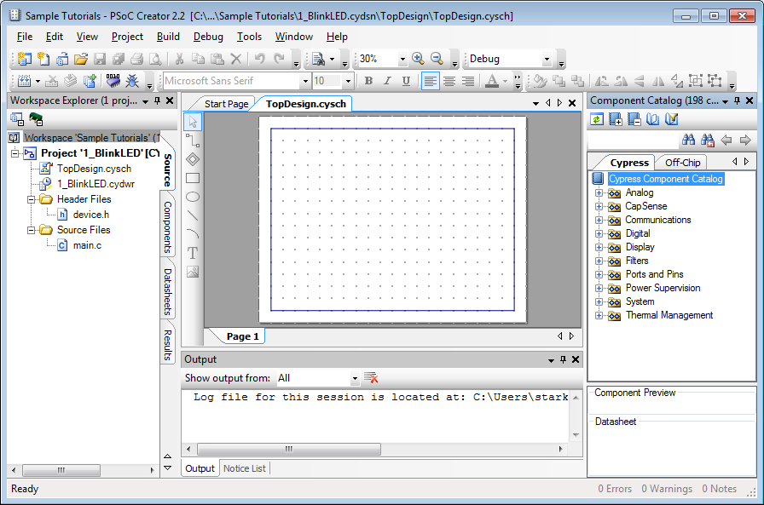

There are two main steps to writing a NeoMote application.

1. *Adding components and assigning pins*: this part of the process differs significantly from most other microcontroller platforms. Instead of having directly assigned pins on the NeoMote, users can actually specify what they want each pin to do (analog, digital, communication, outputs, etc.). Thus, most pins can have multiple functions, making it easy to use the NeoMote for a variety of applications.
2. *Writing your firmware*: once the hardware components have been assigned and the system-on-chip has been configured, you can begin writing your code. After the hardware is configured, PSoC creator will also generate an API which you can use to seamlessly execute system functions.

## Adding Components

This project is very simple. You will only need to add two components.

* Locate the **Digital Output Pin** component under the **Ports and Pins** group in the Component Catalog. The Component Catalog is found to the right of your blank schematic sheet.

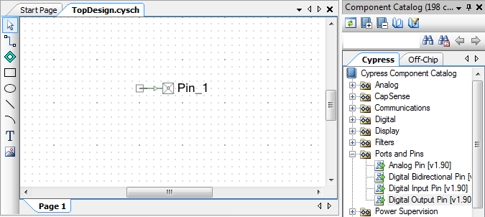

* Drag the **Digital Output Pin** component from the Component Catalog onto the schematic. Use the zoom controls in the top toolbar to zoom if necessary.

**Note**: PSoC Creator has many useful components. You can right click a component to find example projects for that component, and to view the PDF of its datasheet, which describes all of its features and API calls in detail.

* Right click (or double left click) on the Digital Output Pinand select **Configure** from the context menu. The Configure dialog allows you to edit default properties for that component.
* Change the Name of the Digital Output Pin component to **LED_Blue**.

**Note:** Pay close attention to the case of names of the components. The name that you select for each component is used when the project is built to generate names for the associated application programmer’s interface (API) calls. The provided code will not work correctly if the names do not match exactly.

* Since this pin will not be connected directly to any other PSoC components, **uncheck** the checkbox titled **HW Connection.**

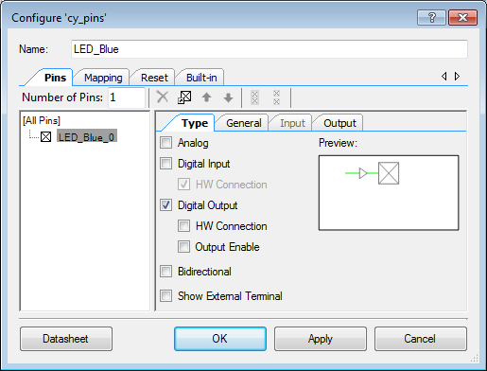

* Repeat the process to add a second Digital Output Pin. Name this pin **LED_Yellow** and uncheck **HW Connection** again. You can also just copy and paste the LED_Blue pin and rename it.

## Assigning Pins

Before building the project, you must tell PSoC Creator which pins to use for each of these digital signals. On the NeoMote, the blue LED is mapped to pin P5[6], while the yellow LED is mapped to pin P5[7].

**Note:** For more information about pin assignments please see the separate pinout application note provided by Metronome Systems.

* Double click the **BlinkLED.cydwr** (Cypress design-wide resources) file in the Workspace Explorer.
* Select the **Pins** tab at the bottom to show the pin configuration of the project. You will see a graphic of the PSoC chip with a description of the I/O pins and routing results.
* Select **P5[6**] for the LED_Blue and **P5[7]** for the LED_Yellow in the Port drop down menu.

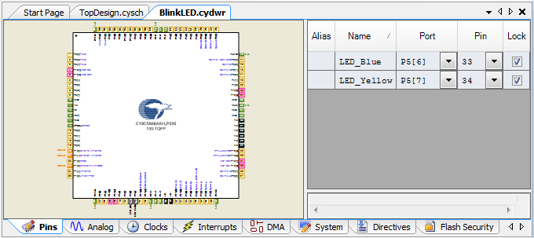

* From the **Build** menu, select **Build BlinkLED**.

**Note:** If the build is successful it will say so in the output frame and there will be new generated source files in the Workspace Editor. If not, see the ***Troubleshooting Failed Builds*** section.

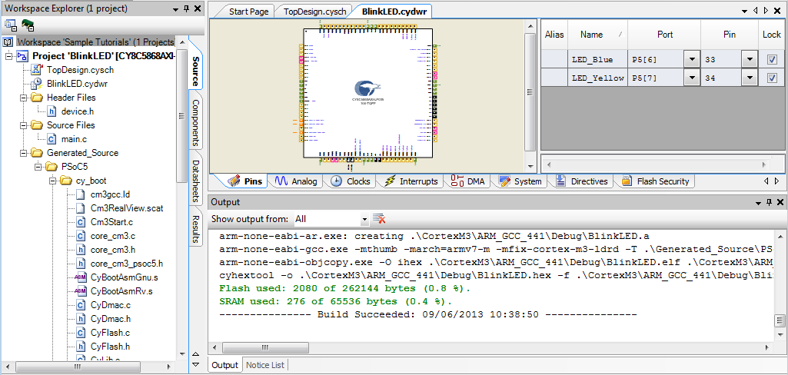

You are now ready to write firmware code. Building the project will generate an API for each of the pin components that you have just created.

## Writing Code

PSoC Creator generates much of the code needed for this project. Open **main.c** by double clicking it under **Source Files** folder in the **Workspace Explorer**.

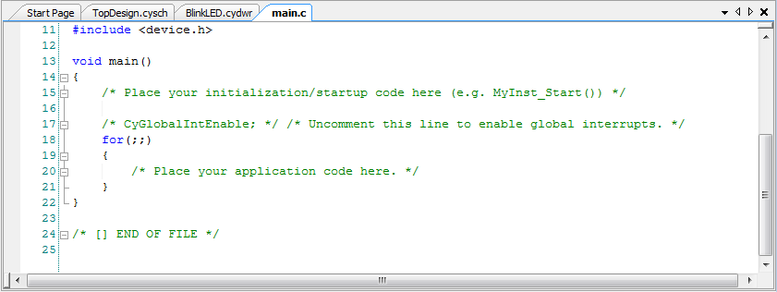

**Note:** Lines enclosed by **/\*** and **\*/** or which begin with **//** are comments. These are ignored by the processor but are great for explanations of code functions and to keep information useful to other people using the code. They are often colored green.

The code needed in the main.c file is quite concise for our simple project and is included below in its entirety. All we will do is run a never ending loop, which will turn the LEDs on and off for a specific duration of time. Please edit your main.c code, and add the **bolded** code below.

#include <project.h>

int main()

{

for(;;) //Never ending loop – Equivalent to *while(1)*

{

**LED_Blue_Write(1u);**

**LED_Yellow_Write(0u);**

**CyDelay(200u);**

**LED_Blue_Write(0u);**

**LED_Yellow_Write(1u);**

**CyDelay(200u);**

}

}

The above code writes a logical 1 (high) value to our LED_Blue pin and a logical 0 (low) value to our LED_Yellow pin. Since the LEDs are connected to two digital pins, the operations are equivalent to flipping a pin high or low. The code then pauses for 200 milliseconds by calling the CyDelay() function, which is part of the standard PSoC library. The code then switches the state of the LEDs and keeps looping.

**Note:** ‘1’, ‘0’ and ‘200’ have a trailing ‘u’ to signify that they are *unsigned* meaning strictly positive integers.

* To build your project again with this new code click **Build -> Build BlinkLED**.
* To load the code onto your NeoMote, click **Debug -> Program**. The program will compile and will load onto your NeoMote.

*Congratulations!* You just compiled your first NeoMote program.

**Note:** If your hardware is not blinking its LEDs, see the ***Troubleshooting Failed Compiles*** section.

**Note:** Instead of using the top menu to build your code, you can also use the convenient build and debug toolbar.

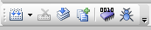

**Build and debug toolbar**

## A Quick Note on Debugging

While you may be familiar with using LEDs for debugging purposes, the true power behind PSoC creator lies in its advanced debugging interface. You can place breakpoints to halt the execution on of the code. During these breaks, you can also read the values of variables or memory locations. We will quickly explore this feature and leave the reader to consult the PSoC Creator manual for advanced debugging functionalities.

* Right click the line in the code with the first instance of **CyDelay(200u)** and **Insert Breakpoint**.
* Insert another breakpoint on the second instance of **CyDelay(200u)**.

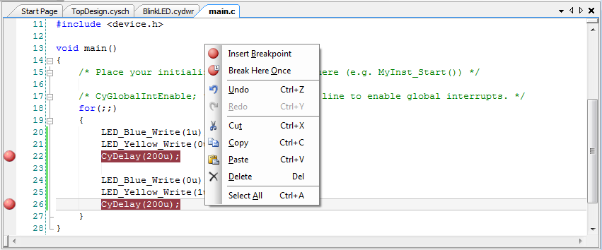

* Now use the Debug menu, or Debug toolbar, and click **Debug** to start the debugger. The debugger will start and pause on the first line of code in the *for(;;)* loop. This will also bring up the debugging toolbar:



* Click the green **Play** button in the debug toolbar. Every time you click play, the code will advance to the next breakpoint in the sequence. The yellow arrow marker on the left edge indicates the current location of the debugger in the code.

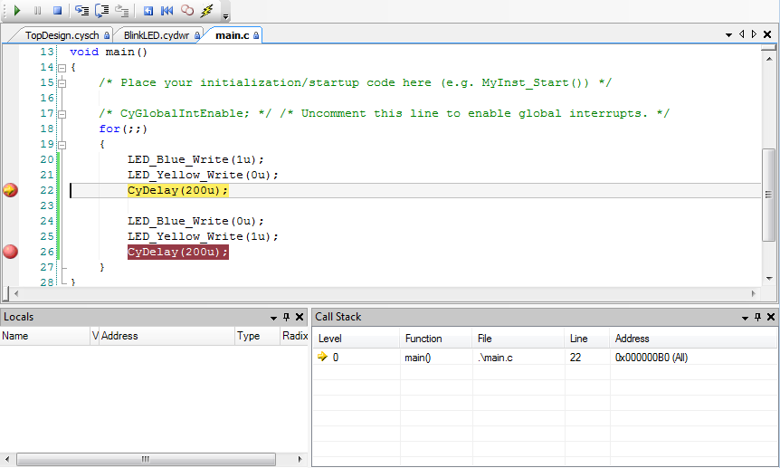

**Note:** Since we are in a *for(;;)* loop, which continues indefinitely, the code will now just alternate between on-and-off states of the LEDs. Watch the LEDs on your NeoMote turn on and off as you keep clicking play.

**Note :** If we had declared any variables at this point, you would be able to hover over the variable name with your mouse to reveal its current value. This functionality will prove very useful for future tutorials.

* Feel free to play around some more with the debugger before continuing. You can click the blue square **Stop** button to exit the debugger.

*Sweet!* You are now done with your first NeoMote tutorial.

Don’t forget to Save.

**Note:** Building, Programing and Debugging all save the current project before completing their respective tasks. Unsaved files will be denoted with an asterisk in the Workspace Explorer. The entire workspace can be saved by clicking on in in the Workspace Explorer and using *Ctrl + s*.

## More Efficient Implementation of the BlinkLED Code (optional)

If you enjoy programming, you will have likely found the above example code a bit clunky. Why do we have to write six lines of code to turn on some LEDs? This is where the **Read()** function of the Digital Pin API comes in. Edit your **main.c** code to reflect the new **bolded** code below.

#include <project.h>

int main()

{

**LED_Blue_Write(1u);**  // Initialize LEDs – Blue On, Yellow Off

**LED_Yellow_Write(0u);**

for(;;)

{

LED_Blue_Write( **!LED_Blue_Read()** );

LED_Yellow_Write( **!LED_Yellow_Read()** );

CyDelay(200u);

}

}

Much cleaner! The code simply initializes the states of the blue and yellow LED pins. It then uses the **LED_Blue_Read()** and **LED_Yellow_Read()** functions that were generated as part of the Digital Pin API to read the states of the LED pins. The *Read()* functions will return 1u if the pin is high and 0u if the pin is low. By negating the state using the C language **!** operator, we just toggle the state of the LEDs to the opposite of what they were before. While simple, this implementation is much cleaner and expands our use of the PSoC API.

If you are using digital pins for purposes other than driving LEDs, these *Read()* functions will be useful for interfacing with external digital peripherals such as sensors. There are many useful API functions built in to each component in the PSoC Creator. The *Read()* and *Write()* functions are the simplest ways to interact with Digital IO pins.

**Note:** For more in depth description of the PSoC API functions read the Digital Pin Component Datasheet.

# Tutorial 2: Communicating Using the USB Port

## Introduction

This tutorial will teach you how to use the USB port to communicate between the NeoMote and a host PC. Communicating over the USB interface is a great means by which to debug code and transmit data to and from the NeoMote. In this tutorial, we will transmit a simple message to a host computer. Furthermore, instead of using a traditional USB interface (which is also possible on the NeoMote), we will configure the USB interface to show up as a COM port on your PC. This will enable more seamless integration on host computers, on which a number of software packages already exist to communicate with serial ports.

**New Requirements:** *Software* – Serial Communication Program (Putty), USB Drivers (Included with windows)

## Creating a New Project

**Note:** Before creating a new project, it is suggested that you close all the windows from the previous project. This can help avoid confusion between projects, particularly due to the fact that all **main.c** files share the same name and appearance.

In your Workspace Explorer, **right click** on your **Workspace ‘Tutorials’** and select **Add -> New Project**. Create a new **PSoC5LP** project called **USBSerial**. PSoC creator will now open into schematic view.

## Adding Components

This project is very simple. You will only add one component.

* Locate the **USBUART** component under the **Communications** group in the Component Catalog.

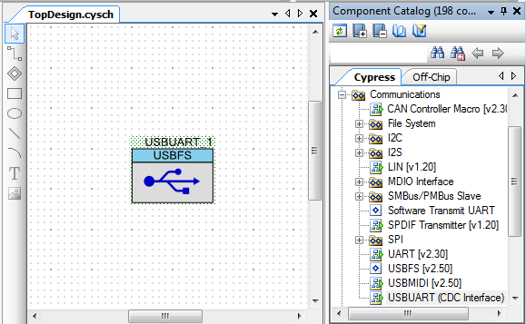

* Drag the **USBUART** component onto the schematic. Leave the default configurations in place.

**Note:** Even though we are not changing any configurations for the USBUART, you are welcome to double click the USBUART component to explore its various settings. You can also consult the USBUART datasheet for more information.

## Assigning Pins

The USB component only uses two pins. The USB pins on the PSoC5 are some of the only pins that must use designated numbering. As such, PSoC Creator will only allow you to select these pins for your USBUART component.

* Double click on the **USBSerial.cydwr** file from the Workspace Explorer.
* Select the Pins tab at the bottom to show the pin configuration of the project.
* Select **Pin P15[7]** for **USBUART_1_Dm** and **P15[6]** for **USBUART_1_Dp**. These will be the only options.

## Clock Settings

The PSoC5 on the NeoMote has a number of clocks. Depending on the application needs, these clocks can be set to a variety of frequencies. For most applications, the default clock settings will be completely adequate. In some cases, however, it may be necessary to increase the clock frequencies to support high fidelity applications. By default, the PSoC5LP runs on a 3MHz internal clock. Modern USB communications require a 48MHz clock however. This is no problem, as all we need to do is change some basic settings in our project file.

Changes must be made in the **Clocks tab** in the design wide resources file (USBSerial.cydwr) to use USB on the PSoC 5 device. The clocks can be configured by clicking **Edit Clock** in the Clocks tab.

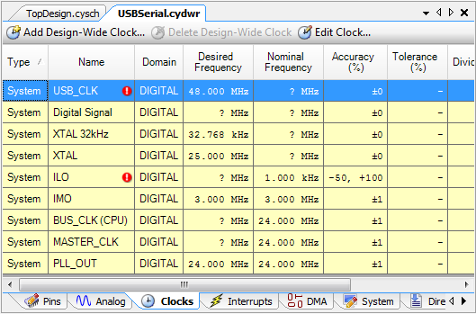

Make the following changes.

* IMO: Select **Osc 24.000 MHz ±4%**
* PLL: Select Input **IMO (24.000 MHz)**. Set Desired frequency to **48 MHz**.
* ILO: Select **100 kHz**.
* USB: Click check box to **Enable**. Select **IMOx2 – 48.000 MHz**.
* Master Clock: Select **PLL_OUT– 48.000 MHz**.

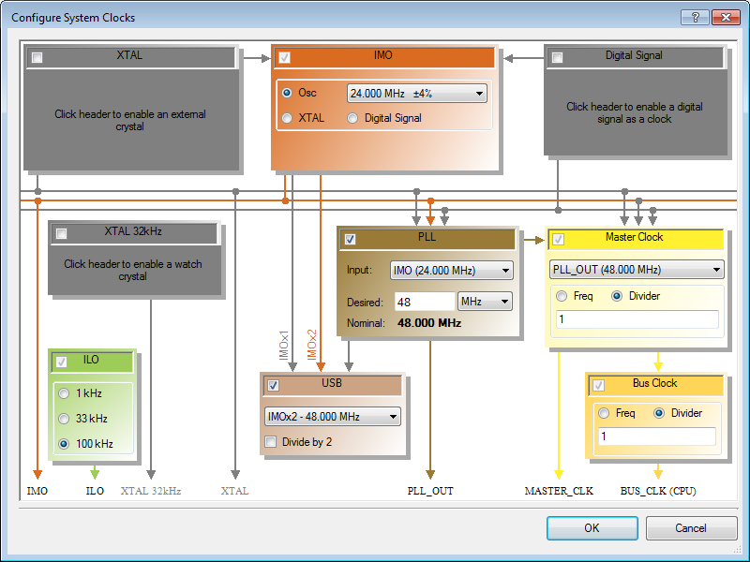

**Note:** Description of the clock resources is beyond the scope of this document. For more in depth explanations of these settings, refer to the Cypress documentation. As long as your settings reflect those in the figure above, the USB UART will be capable of communicating with a computer.

## Building the Project

Now build the USBSerial project. To build the specific project you are working on in your workspace, use **Shift + F6**. This will generate any API calls for the USBUART_1 component. It will also create the MS Windows USB driver that you will install to communicate with the device in a later step.

## Adding Code

Open **main.c** by double clicking it in the **Workspace Explorer**. The code needed in the main.c file is quite concise for our simple project and is included below in its entirety. All we will do is run a never ending *for* loop, which will print a messaged to the USB port.

#include <project.h>

**#include "USBUART_1.h"**

int main()

{

CYGlobalIntEnable;

/* Initialization Code: */

**USBUART_1_Start(0, USBUART_1_5V_OPERATION);**

**while(!USBUART_1_bGetConfiguration());**

**USBUART_1_CDC_Init();**

for(;;)

{

**USBUART_1_PutString("I <3 NeoMote!\n\r");**

**CyDelay(1000u);**

}

}

## Code Explanation

* The code first includes the USBUART header file to allow us to use the USBUART API.
* We then enable Global Interrupts by calling the CYGlobalIntEnable C macro.

**Note:** Calling this macro will be done in most applications, as it allows external interrupts (signals) to wake up our chip. We will call this macro in all future tutorials, and you will need to likely call it in all of your own applications.

* The USBUART_1 component is the initialized by calling the Start() function.
* We then loop until the bGetConfiguration() returns 1. This means that the NeoMote has completed communicating with the host PC and is ready for use.

**Note:** If a connection cannot be established with the host PC, the code will simply hang in this *for* loop. You should consider building in a timeout feature for real-world applications.

* We then initialize the CDC interface, which prompts the host PC to enumerate the USB device. This will make the device register as a COM port on the PC.
* The final section is the endless loop that just prints a string using the PutString() function to the USB interface once every second. We delay for 1000 milliseconds (1s), using CyDelay(), before printing the message again.

**Note:** While the USB interface on the NeoMote has some very advanced features, you will, in most cases, just be able to copy and paste the above code into your own applications to achieve basic USB communication functionality. For advanced features and other API calls, please see the USBUART datasheet in PSoC creator.

## Building and Running the Code

As in the previous tutorial, build your completed code and load it on the NeoMote using the MiniProg3 connector. Click **Debug -> Program**. This will install the code on the NeoMote.

Your Windows PC will now prompt you to install the drivers for the USB interface. This will only happen once and is explained in detail below.

## One Time Installation of USB Drivers

Once the NeoMote is connected via the USB and the device is programed with the above code, your computer will detect the new device.

* A *Driver Software Installation* page may open automatically on your PC. Ignore it. We will do the next steps manually.
* Open the **Windows Device Manager**.

**Note:** Windows Device Manager can be found by right clicking **My Computer** and selecting **Manage**, then selecting **Device Manager** in the navigation tree on the right. On machines with Windows 7 or forward, you can simply search in the Start menu for it by typing device manager.

* The NeoMote should be shown as unknown **USBUART** component under **Other Devices**. You may also see an “Unknown device message.”

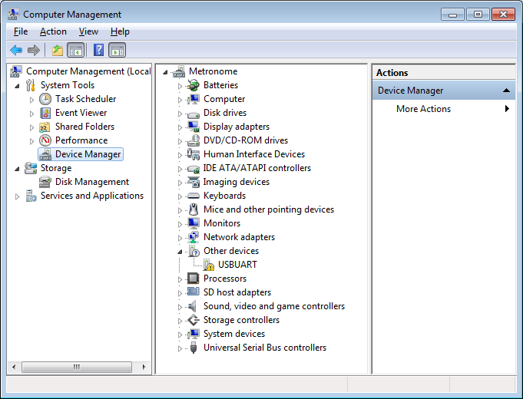

* Double click USBUART to bring up its properties.
* Click **Update Driver**
* When prompted, select**Browse my computer for driver software**.*Do not install automatically.*
* Navigate to the project folder that you have created for the USBSerial project.
* Inside the folder, navigate to **\USBSerial\USBSerial.cydsn\Generated_Source\PSoC5\**
* Selecting this folder will be enough for Windows 7 and forward. If your computer requires it or you want to, you can select the generated a driver file called **USBUART_1_cdc.inf**.
* Windows may show a warning message, saying that the driver publisher is not verified. If this is the case, click **Install this driver software anyway**.

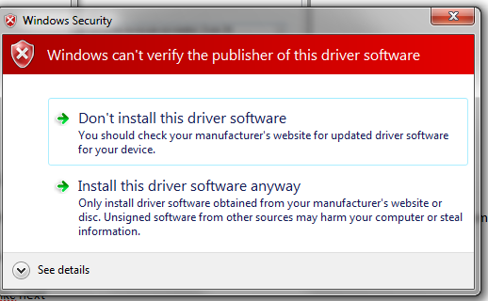

* The driver is now installed, and is enumerated as a COM-port on your computer.

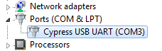

**Note:** The port number (In this example COM3) **will differ** depending on your system. Check and remember this number for your computer, as it will be used in the next step and later tutorials. The port number should be fixed regardless of which USB slot you use to connect your NeoMote.

## Testing the Firmware

To test your new project, you need to use a serial communication program to connect to the program you just built for the NeoMote. For the purposes of this tutorial we will use the simple, free, open-source communication program Putty ([www.putty.org](http://www.putty.org/)).

* Open your serial program of choice.
* Make sure you are in serial mode.

**Note:** Putty allows several different modes of communication including but not limited to Serial. Other clients are often dedicated serial communicators and will not need to be set to serial mode.

* Type the com port your NeoMote is connected on from the previous section. (e.g. COM3)

**Note:** Since we have not set a requisite baud (Speed) rate on the NeoMote end it will communicate at whatever baud you select in Putty.

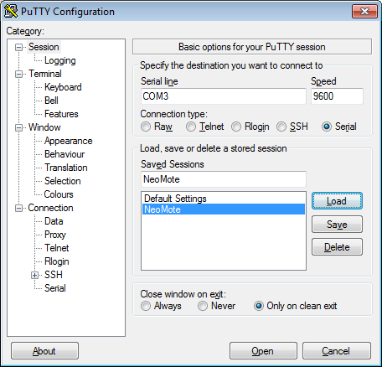

**Note:** You can also type a name for these settings (NeoMote) and save them for easy use in the future. Simply double click the saved session next time you open Putty and it will automatically connect.

*Congratulations!* You have completed a second tutorial giving you the ability to send information from the NeoMote. The next step is to get some data worth sending to the computer.

# Tutorial 3: Reading from an Analog Sensor

## Introduction

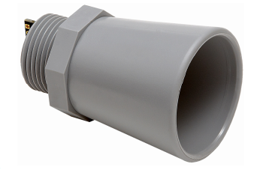This tutorial will teach you about one of the most fundamental features of embedded sensing. Namely, we will use one of the three analog to digital (ADC) converters on the NeoMote to read from an analog sensor. In this example, we will use the *MaxBotix MB7364 Ultrasonic Distance Sensor*. This MaxBotix distance sensor is a powerful sensor that can be used to quickly measure the distance between the sensor and some object. It can also, for example, be used to measure the depth of snow and the height of water in a tank. We will be using this sensor in Analog mode, which means it will output a voltage proportional to measured distance.

## Connecting the sensor

We will connect the humidity sensor to the VWC1 port on the EnvBoard.

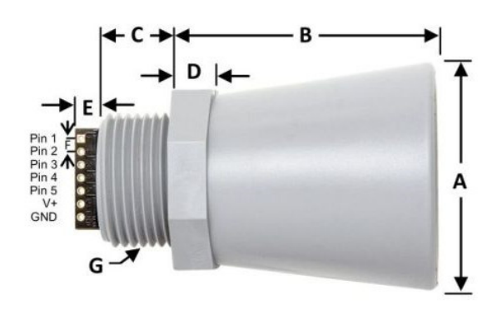

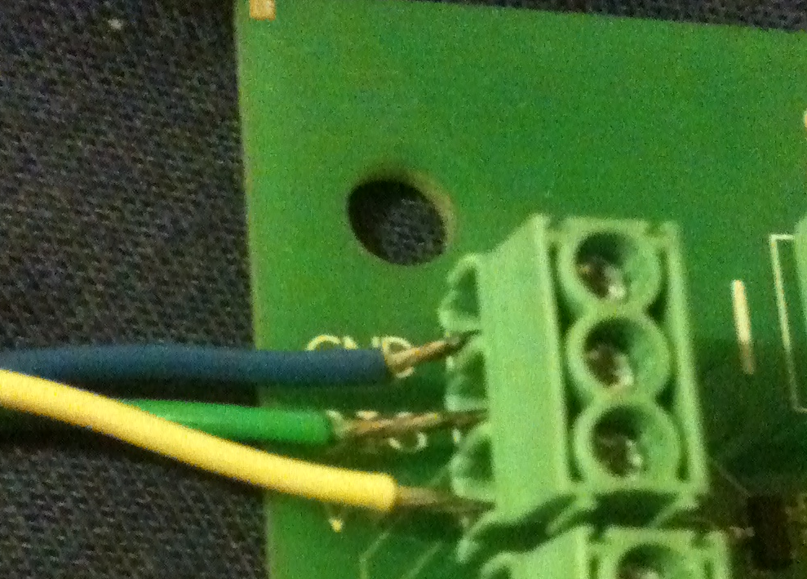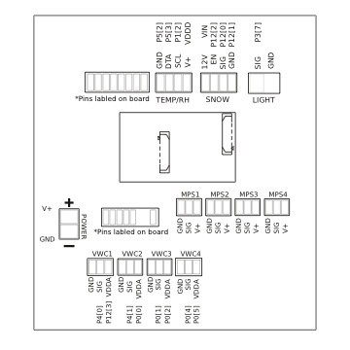

Pin 3 (Analog) – Connect to SIG on EnvBaord

Pin V+: Connect to V+ on EnvBoard

Pin GND – Connect to GND on EnvBoard

* Note: your wire colors may differ. If they do, just please ignore the color directions and just use the pin connection information. Using the small Philips-head screwdriver, place the wires from the ultrasonic sensor in the clamps and tighten. For each of the below, use port VWC1 on the Environmental sensor board.
  + Connect the **blue GND** wire on the sensor to the **top GND** wire terminal on the Environmental Board.
  + Connect the **green Pin 3 Analog wire** on the Sensor to the **middle SIG** wire terminal on the on the Environmental Board.
  + Connect the **yellow V+** wire on the sensor to the **V+** wire terminal on the Environmental Board.

The yellow and blue wires provide power to the sensor and the green wire outputs the analog signal. This sensor uses a 5V power source, which is why we placed it at the terminal we did. These terminals are set to 5 volts by the jumpers configured on the NeoMote. If you intend to use a sensor with a different voltage requirement you should first read **AN-1 Adjusting Power Supply Levels**.

**Note:** For more information about the Honeywell sensor, see its datasheet: **HIH-4030 Datasheet.pdf**

## Analog to Digital Converters on the NeoMote

The NeoMote has three analog to digital converters, each of which can be used simultaneously for making analog measurements:

* Two 12 bit Successive Approximation (SAR) ADCs – While accurate, these ADCs are specifically designed for rapid measurements.
* One adjustable 20 bit Delta Sigma ADC – This is the power horse of the NeoMote. It is a 20 bit, ultra-low noise ADC. The accuracy is adjustable, from 8 to 20 bits, with lower resolutions corresponding to higher sampling rates.

**Note:** For advanced applications requiring many analog sensors, the above ADCs can be multiplexed to permit for many analog sensors to be sampled.

**Note**: The NeoMote is designed to be an ultra-low noise sensing platform. For most applications a resolution of 16 bits and less will be sufficient. The default jumper settings shown in the Hardware Setup section will facilitate these performance levels. If your applications demands ADC resolutions of 18-20 bits see Application Note 2 – Low-power Low-noise Sensing.

## Creating a Duplicate Project

**Note:** Again, remember to close all USBSerial tabs before starting your new project. This is even more important this time as we will be copying USBSerial to build upon it.

Instead of creating a new project, we can just build upon the previous USBSerial project that we created in the previous tutorial.

* To preserve your previous work, you can either:

1. Select **File -> Save USBSerial As**. Then find the **Tutorials** folder the rest of your projects are in and Save as **AnalogSensor**. Then right click on your Workspace and **Add -> Existing Project** and select the **AnalogSensor.cyprj** file in the AnalogSensor folder.
2. **Copy** **USBSerial** in the Workspace Manager. **Paste** it back into your Workspace. It will be named USBSerial_Copy_01, so **Rename** it as **AnalogSensor**.

* If it is not set as your active project, right click and **Set As Active Project**.

**Note:** We will use these methods for creating the projects for the rest of the tutorials. This allows us to accumulate functionality with each successive tutorial while preserving working copies of each step for reference and backup.

## Adding Components

* In the schematic view, drag and drop the **Delta Sigma ADC** component onto your schematic. The component is located in the **Analog -> ADC** folder in the component view.

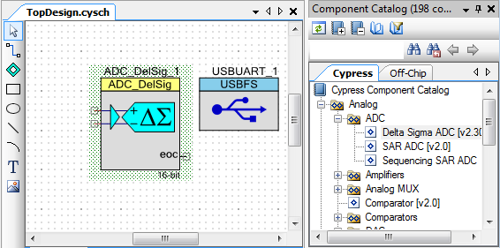

* Double click the **ADC_DelSig_1** component on your schematic to adjust its settings.

**Note:** The Delta Sigma ADC has a very wide variety of uses and possible settings. **Right Click -> Open Datasheet** to learn more.

* One of the fundamental settings of an ADC is its *Input Mode*. The input mode can either be single ended or differential.

**Note:** Single ended inputs are a voltage difference between the signal wire and the ground wire 0-X volts. A differential input has two signal wires, one connected to the positive ADC input, and the other to the negative ADC input. This gives a range that does not necessarily start at zero, and can even potentially begin negative (–X volts to Y volts). Depending on the sensor you are using, reading the datasheet will likely inform you of the correct input mode.

* Our Honeywell humidity sensor has only a single signal wire. So we will use we will use the *Single* inputmode.
* Looking at the sensor datasheet for the MaxBotix Distance sensor, we can see the output signal can vary between 0-5V. We thus need to make sure that the ADC range is set in a way to capture this range in sensor output.

**Note:** This sensor can also be configured to run in digital mode using the RS232 connection. This can be easily configured on the NeoMote, but we’ll stick the analog output for this tutorial.

**Note:** If you do not have this sensor available, you can just measure the voltage of an AA battery as a substitute using the same settings.

We will use most of the default configuration but make sure the following settings are applied:

* Resolution: **16 bits**

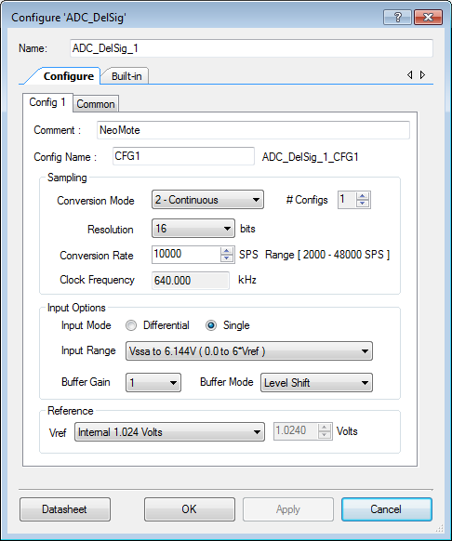

* Vref: **Internal 1.024 Volts**
* Conversion Rate: **10000** (Samples/Second)
* Input mode: **Single**
* Input range: **Vssa to 6.144V (0.0 to 6*Vref)**
* Buffer Mode: **Level Shift**
* The Delta Sigma ADC in single mode requires only one input. In your schematic, drag and drop **Pins and Ports ->** **Analog Pin** components and connect it to the Delta Sigma ADC using the **Wire Tool**. Name this pin **P_in** by double clicking it.

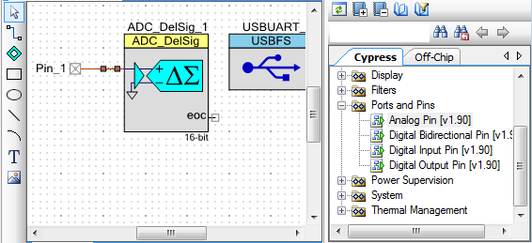

We do not want the sensor to stay on all the time and simply consume power. We would like to turn it on before use, and turn it off after use. In the case of the environmental sensor board used in this tutorial, the V+, or voltage inputs, on your breakout board are equipped with PMOS switches. These switches are connected to one of the PSoC’s pins. When the pin is flipped high (logic 1), the switch will not deliver power to the sensor. Alternatively, when flipped low (logic 0), the switch will deliver power to the sensor. To use this feature, we can just simply drag and drop a digital output pin component to the schematic.

* Place a **Digital Output Pin** on your schematic. Call this pin **Analog_Sensor_Power**, and **Remove** the **Hardware Connection** option.

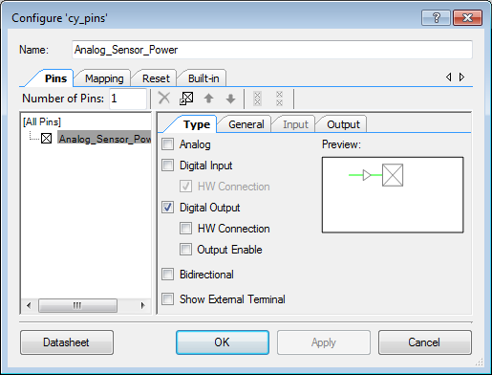

By default, the outputs of digital output pins are turned low (logic 0). To make sure the sensor starts in the OFF (which requires a digital high) condition we must change the properties of the pin.

* Under the **General** tab, set the Drive Mode to **Resistive Pull Up**, and the Initial state to **High (1)**.

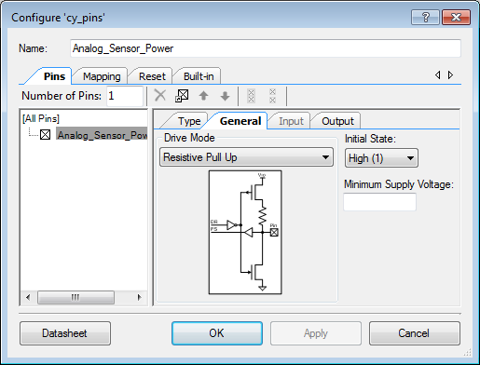

## Assigning Pins

For this tutorial we will be connecting the MaxBotix distance sensor to VWC1 port on the environemtnal sensor board. Each of the three wires must be connected to their respective trace on the Environmental Sensor Board. GND to GND; 0V to SIG; 5V to VDDA. This means that our signal will be located on pin P4[0] and our analog sensor power will be P12[3].

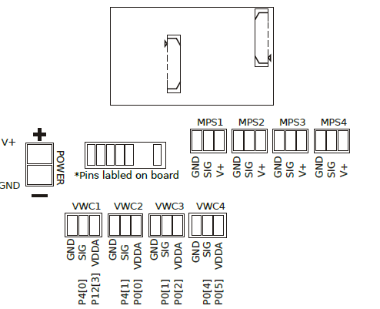

* Open **AnalogSensor.cydwr**.
* Set **Analog_Sensor_Power** to **P12[3]**.
* Set **P_in** to **P4[0]**.

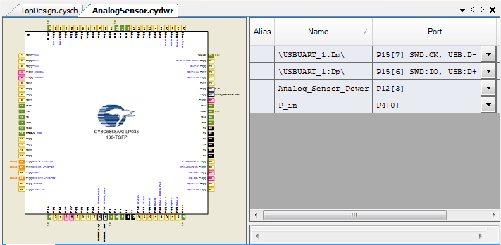

## Adding Code

Open **main.c** by double clicking it in the **Workspace Explorer**. We will modify the code from the previous section. Instead of writing a predetermined string to the USB interface, we will write the values recorded by the ADC. The sensor just outputs a voltage, which we measure using the ADC. To get the actual distance, we have to convert this reading. The datasheet specifies that “the HRXL-MaxSonar-WRS sensors use a scale factor of (Vcc/5120) per 1-mm.” If we read the voltage, we can then get the distance in mm using the following formula:

distance = voltage*(5120/5);

Vout is the output of the sensor in volts. You will then be able to use your favorite PC terminal interface to display the sensor readings.

Note: This time we will create an external function **Take_Distance_Reading().** This will allow for cleaner code and modularity.

#include <project.h>

#include <stdio.h>

**#include <stdlib.h>**

**#include "ADC_DelSig_1.h"**

float Take_Distance_Reading();

int main()

{

/* Initialization Code: */

CYGlobalIntEnable;

USBUART_1_Start(0, USBUART_1_5V_OPERATION); // Initialize and start the UART.

while(!USBUART_1_bGetConfiguration());

USBUART_1_CDC_Init();

**ADC_DelSig_1_Start(); // Initialize and start the ADC.**

**ADC_DelSig_1_StartConvert();**

for(;;)

{

**float distance = Take_Distance_Reading();**

**char sendBuffer [64];**

**sprintf (sendBuffer, "Distance: %2.2f% mm\n\r",distance);**

USBUART_1_PutString(sendBuffer);

CyDelay(1000u); // Wait a second before the next reading.

}

}

**float Take_Distance_Reading(){**

**//turn on sensor and delay briefly to let it settle**

**Analog_Sensor_Power_Write(0u);**

**CyDelay(100u);**

**float distance;**

**if(ADC_DelSig_1_IsEndConversion(ADC_DelSig_1_WAIT_FOR_RESULT) != 0){**

**uint32 adcResult = ADC_DelSig_1_GetResult32();**

**float voltReading = ADC_DelSig_1_CountsTo_Volts(adcResult);**

**//Conversion factor Vcc/5120**

**distance = voltReading*(5120/5);**

**}**

**//turn off sensor**

**Analog_Sensor_Power_Write(1u);**

**return distance;**

**}**

**Important Note!** As of PSoC creator 3.0, the default linker libraries do not allow the formatting of float values using printf. There are several solutions to this problem. You can either opt not to use floating points through converting them to integer pairs, add the printf linker libraries yourself, or disable the new libraries that PSoC creator defaults to.

Since the NeoMote has a lot of memory we do not need to be concerned about an increase in library memory use, you can just switch back to the old link library. Go to **Project ->** **Build Settings -> ARM GCC -> Linker -> General** and setting the **Use newlib-nano** option to **False**.

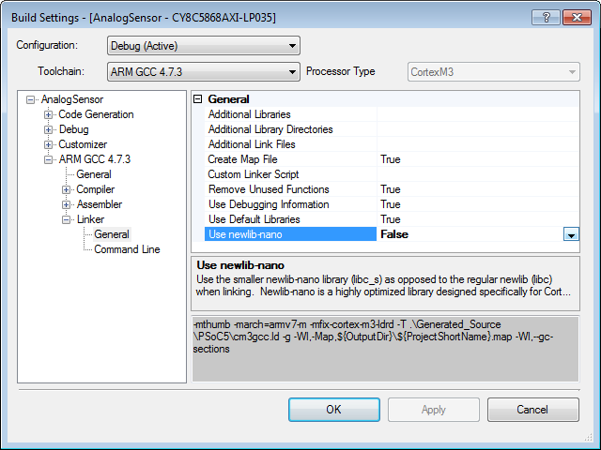

Alternatively you can simply add the line “**-u _printf_float**” to the **Command Line** for the linker, just below. This option takes less space but ONLY restores float functionality to printf.

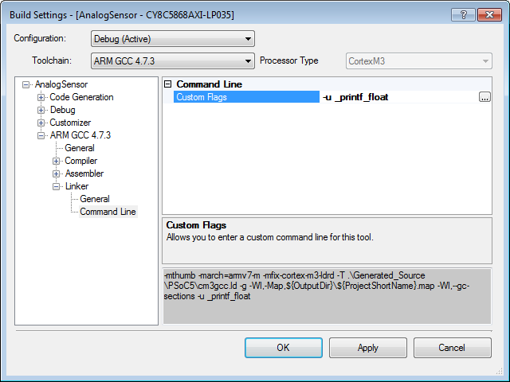

## Code Explanation

The **ADC_DelSig_1.h** file must be included to use the Delta Sigma API. If you are familiar with *C* programing, you may have also noticed that we included **stdio.h** and **stdlib.h** files to support standard input/output and string operations.

**Note:** Header files, those ending in “.h”, allow for the use of functions already written by others. By including the header file at the of your main.c file, you are able to call functions described inside the file. For example, stdio.h allows us to use sprintf() to format our strings.

The ADC must be started and told to begin making measurements. This is done by calling the **ADC_Start()** and **ADC_StartConvert()** functions.

We then enter a never ending, for loop taking an ADC sample and writing it to the USBUART interface. We then pause for one second before repeating the same step. The measurement is actually taken by the Take_Distance_Reading() function, which we have declared for this purpose. The function returns the ADC reading value when the measurement has been completed. The first step is to provide power to the sensor, which is done by calling **Analog_Sensor_Power_Write(0u**). We then delay the code for 100 milliseconds to give the sensor time to settle.

Within the Distance Reading function, before we read the measurement from the ADC’s memory, we need to make sure that the ADC has made a measurement and that the measurement is ready for processing. We check by calling **ADC_DelSig_1_IsEndConversion(ADC_DelSig_1_WAIT_FOR_RESULT).** This function will return a nonzero value when the ADC has made a reading. To read the ADC measurement, we call the **ADC_DelSig_1_GetResult32()** function. This function will return an integer value, ranging from 0 to 2^N, where N is the number of bits (or resolution) of the ADC. What’s actually more useful in this case is the Voltage of the ADC measurement, as opposed to the integer value. Luckily, the API provides us with a simple conversion. By calling ADC_DelSig_1_CountsTo_Volts(), we can convert the integer value to a floating point voltage value.

**Note:** The API also supports methods to make conversions to milli-, and micro-volts. To learn more, read the datasheet for the ADC component.

We then take this reading and plug it into the sensor calibration equation from before to obtain distance. Finally, we use sprintf to turn the data string into a useful phrase to convey the information through the UART.

**Note:** Read the sprintf documentation to get a better understanding of how it processes string formatting. We use it to change the humidity float to the format XX.XX, and surround it with text to make its value clear to anyone reading the serial port.

## Running the Code

Build and program your code. Connect the sensor to your breakout board, making sure the GND and 5V lines are connected correctly. As in the previous tutorial, open a terminal program. Watch the sensor readings change on screen. For more dramatic changes try breathing onto the sensor.

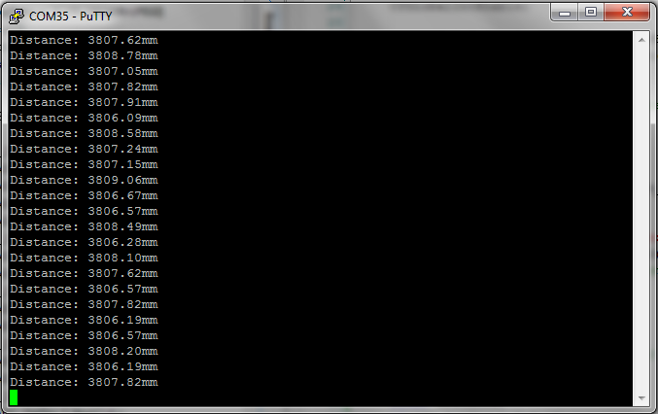

*Congratulations!* You have completed your third tutorial and now you know the basics of using the Delta Sigma ADC.

**Note:** If you do not use a single ended sensor, but rather a differential sensor, changing this example to differential mode is as simple as changing the ADC settings. A separate differential sensor example project has been included in the attached zip file for your reference. Please also refer to the ADC documentation in PSoC creator for detailed descriptions of other available features.

# Tutorial 4: Reading from a Digital Sensor

## Introduction

While the analog accuracy and flexibility of the NeoMote are unparalleled, it is still possible to connect a large number of external peripherals via standard digital interfaces. Virtually any digital interface can be connected to the PSoC chip on the NeoMote, and a number of standard interfaces are easily configured, including but not limited to, UART, I2C, SPI, CAN, and USB. The configurable digital blocks on the PSoC5 also facilitate extreme flexibility; almost any pins can be configured to serve as digital connectors. Both 3V and 5V logic levels can be supported simultaneously, thus allowing various digital peripherals to be connected to the NeoMote at the same time.

To showcase the ease with which digital peripherals can be connected to the NeoMote, this tutorial will show you how to interface and read from a digital serial sensor. In this example, we will be using the **Sensirion SHT25** temperature and humidity sensor. The sensor is powered by a 3.3V volt power source, which the NeoMote provides.

**New Requirements:** *Hardware* – Sensirion SHT25 sensor

**Note:** If you have not obtained an SHT25 sensor as part of your Metronome Systems order, you can easily order it online.

## About I2C Digital Communications

It’s pronounced I-squared-C, but I’ll still call is I-two-c. I2C is a low power digital protocols that allows two devices (sensor and controller, for example) to exchange information. I2C communications have a Master device and a Slave device (see picture below). While the NeoMote can be both a master and a slave, we usually just use it in Master mode in sensing applications (see picture below). A typicall exchange entails the Master (NeoMote) telling a slave (sensor) to give it a measurement. That’s not too uncommon and similar to other digital interfaces you may be familiar with, such as serial. Digital data is transmitted on the SDA line. The master also decides how fast data will flow by setting a clock speed on the SCL line. The thing that makes I2C awesome is that multiple slaves (sensors) can share the same channel. This means you can plug a lot (up to 256 theoretically) sensors onto the same SDA and SCL lines. That’s a lot of sensors on only two pins! The way this is implemented is quite elegant. Each slave (sensor) has an address. It listens on the SDA line for incoming commands. Before the master gives any commands, it first sends out the address of the sensor it wants to talk to. This address is one byte (8 bits long). For example, the default address of our humidity sensor is ‘229’ or (11100101 in binary). When the master wants a reading from our senor, it first sends out an address on the SDA line. All sensors that are not address 229 then ignore any subsequent messages. Only address 229 stays awake. This way, we can have a bunch of different devices sharing only two lines. They only responds when called on, and the I2C protocol on the NeoMote helps make this process easy.

## C:\Users\cps\Downloads\photo 1 (1).JPGhttp://www.totalphase.com/support/article_attachments/200093557/i2c-diagram.png

Sensor 1

Sensor2

Sensor 3

NeoMote

**Source**: TotalPhase

Most I2C sensors are simple. When called upon by the Master, they just send their readings everyone goes back to sleep. That’s not true of the sensor in this tutorial. Since it measure both temperature and humidity, we have to tell is which one we’re interested in (see figure below). First we tell it to take a temperature reading. This is done by sending a one byte command (11100011) to the sensor (see sensor datasheet). The sensor will return a two-byte (16 bit) number between 0 and 65535. We can then use this number and convert it via a sensor formula (given in data sheet) to a temperature reading. We repeat the process for the relative humidity reading. Another challenge is given by the fact that we do not actually get a 16-bit integer between 0 and 65535. We actually get two 8-bit (one byte) numbers, one which represents the most significant byte of the 16-bit integer, and the other which represents the least significant byte. Therefore, we have to combine these two numbers into one. This can easily be done in C, as we will soon see.

Hey sensor at address 11100101

I’m here. What’s up?

Give me a temperature reading  
Command: 11100011

OK. Temp 2 bytes =  
 {MSB 011000110, LSB 101 0010}

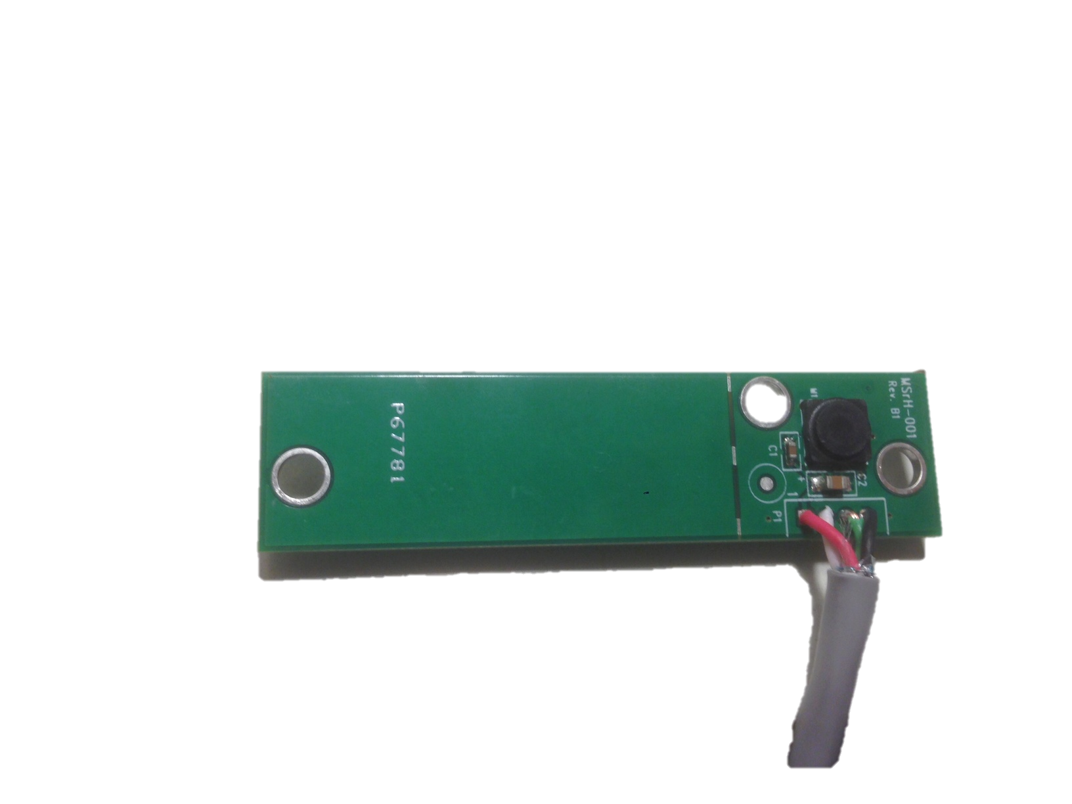

TempRH Sensor

NeoMote

Give me a relative humidity reading  
Command: 11100101

OK. RH 2 bytes =  
 {MSB 011000110, LSB 101 0010}

## Connecting the sensor

The SHT25 uses a digital I2C interface and is a high precision, fast response, high reliability, yet low-cost sensor.

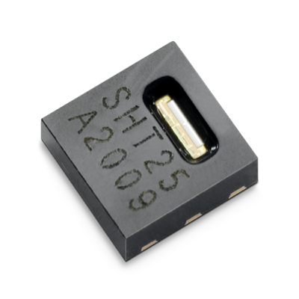

While we can plug it into any of the ports of the environmental breakout board, we have labeled a designated spot at the top of the board. Plug the sensor into the TEMP/RH port on the board. Like the distance sensor above, this sensor simply needs to be connected to the Environmental Board and the rest is handled in software.

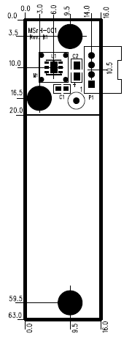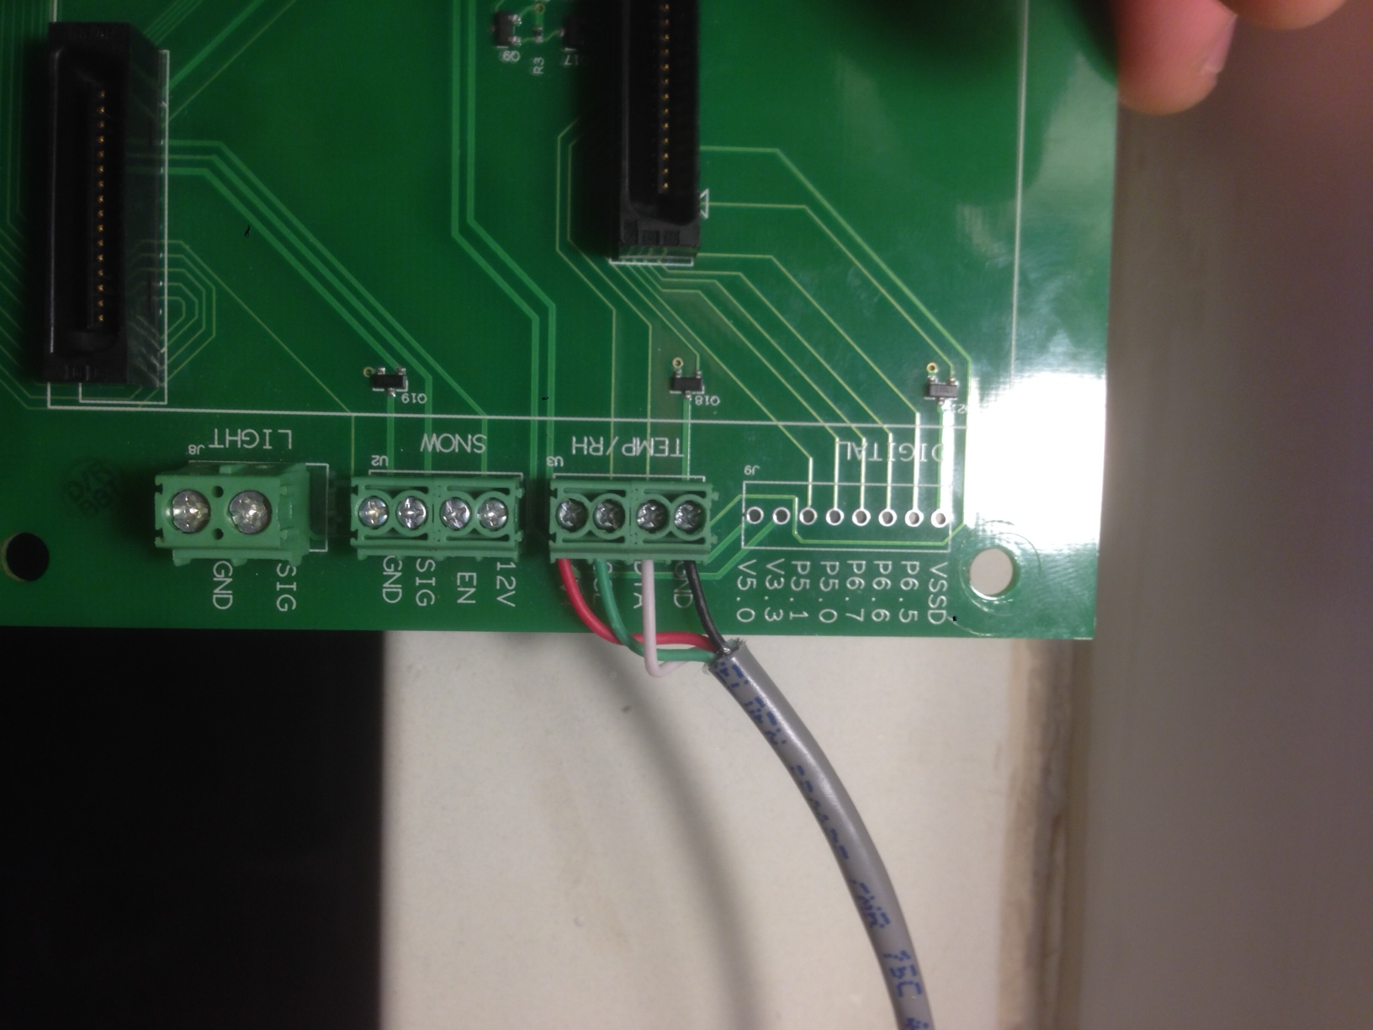

Sensor

Board

GND

SCL

SDA

V+

* Using the small Philips-head screwdriver, place the wires from the humidity sensor in the clamps and tighten. Follow the connection diagram above. All of the pins are labeled on both devices. You will connect four pins: V+ (red), GND (black), SDA (white), SCL (green).s

The black and red wires carry power to the sensor and the white wire carries the digital communication signal. The green wire is the a common clock signal to synchronize the NeoMote to the Sensor.

As indicated in the datasheet, this sensor strictly requires a 3.3V source, which we have set using the jumper settings above.

**Note:** For more information about the sensor, please see the manufacturer datasheet.

## [XXX Change this for I2C XXX] Creating a Project

Now you will want to create another project that builds upon the AnalogSensor project that we created in the previous tutorial. Repeat the process from the previous tutorial to save a copy of your AnalogSensor project while creating a new one called DigitalSensor.

* Drag and drop a **UART** component onto the project from the **Communications** folder.

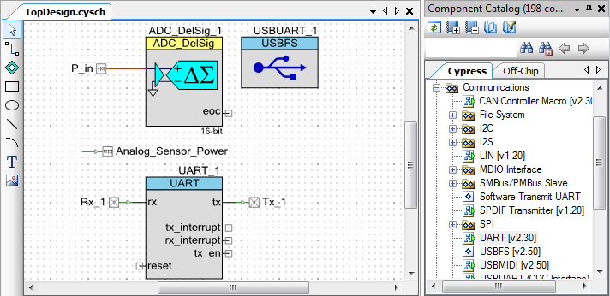

* Double click the UART_1 component to open its settings.
* The sensor we are using does not require data to be sent to it. As such, we will only require a single directional UART. Set its mode to **RX Only** to get rid of the unnecessary transmit side.
* Set the **Bits per second** (Baud rate) to 9600.

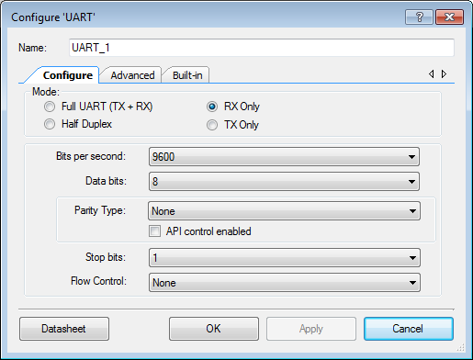

The UART component in your PSoC schematic has a **Reset** connection. For the component to be enabled in hardware, this reset pin must be pulled low. Do this by dragging and dropping a logic low (or zero) onto the connection.

* Go to the **Digital -> Logic** folders and drag and drop a **Logic Low** component to your schematic.
* Connect it to the **UART** component as shown below.

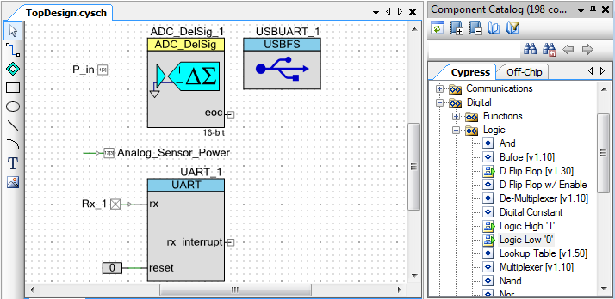

**Note:** For almost all digital serial interfaces, the above setup will work fine. However our sensor requires an extra step. Reading the datasheet for your sensor will tell you whether it has usual or inverted logic.

The Maxbotics sensor is somewhat unusual. Occasionally sensors will have logic levels that are inverted from traditional UART sensors. When it writes a 0, other sensors would typically write a 1, and vice versa. Luckily, we can fix this easily in the Schematic.

* Go to the **Digital -> Logic** folders and drag and drop a **Not** component to your schematic.
* Connect it to the **rx** connection of the UART component.

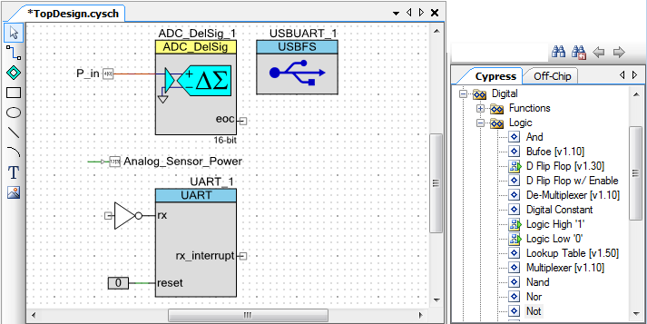

This will invert the incoming signal, turning all 0’s to 1’s and vice versa. This should illustrate to you the flexibility of the PSoC chip and how simple it still is to interface any digital interfaces, regardless of little differences between manufacturers.

* Add another digital input pin to your schematic with default settings and call it **Sen_RX** and connect it to the **Not** component you just added.

As in the previous tutorial, to conserve power, we do not want to power this sensor when it is not taking readings.

* Copy and paste the Analog_Sensor_Power pin from before. Rename it **Digital_Sensor_Power**.

## Assigning Pins

You will be connecting the sensor to the environmental sensor board, right adjacent to the analog sensor your connected earlier. Do not disconnect the analog sensor since we will be using its readings in this tutorial as well.

* Set Sen_RX to **P4[1]** and Digital_Sensor_Power to **P0[0]**.
* Build your code.

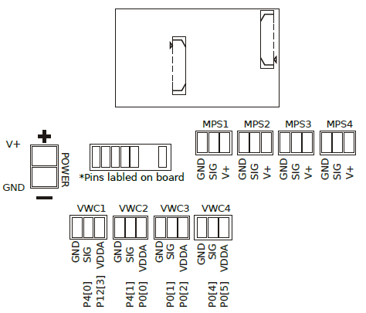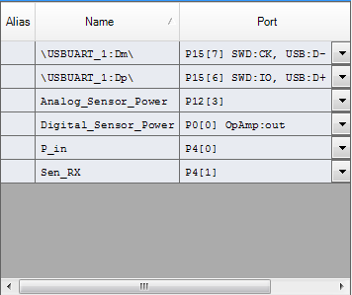

## Adding Code

We slightly augment to include a new function Take_Depth_Reading(), which will read the serial string output from the sensor and return its value. Change your code in main.c to reflect the new code below.

#include <project.h>

#include <stdio.h>

#include <stdlib.h>

#include "USBUART_1.h"

#include "ADC_DelSig_1.h"

#include “UART_1.h”

float Take_RH_Reading();

**uint8 Take_Depth_Reading();**

int main()

{

CYGlobalIntEnable;

USBUART_1_Start(0, USBUART_1_5V_OPERATION); // Initialize and start the UART.

while(!USBUART_1_bGetConfiguration());

USBUART_1_CDC_Init();

ADC_DelSig_1_Start(); // Initialize and start the ADC.

ADC_DelSig_1_StartConvert();

**UART_1_Start(); // Start the UART.**

for(;;){

float RH = Take_RH_Reading();

**uint8 depth = Take_Depth_Reading();**

char sendBuffer [64];

sprintf(sendBuffer, "Relative Humidity: %2.2f**%%, Depth: %d\n\r**", RH**, depth**);

USBUART_1_PutString(sendBuffer);

CyDelay(1000u); // Wait a second before the next reading.

}

}

float Take_RH_Reading(){ … } // No changes here…

**uint8 Take_Depth_Reading(){**

**char digitalSensorData[3];**

**uint8 digitalSensorDataCount = 0;**

**uint8 sensor_depth = 0;**

**Digital_Sensor_Power_Write(0u);**

**CyDelay(100u);**

**for(;;){**

**if(UART_1_ReadRxStatus() & (uint8)UART_1_RX_STS_FIFO_NOTEMPTY){**

**uint8 rxByte = UART_1_GetByte();**

**if(rxByte == 'R'){**

**digitalSensorDataCount = 0;**

**}else if(rxByte == '\r' && digitalSensorDataCount == 3){**

**sensor_depth = atoi(digitalSensorData);**

**break;**

**}else{**

**digitalSensorData[digitalSensorDataCount] = rxByte;**

**digitalSensorDataCount++;**

**}**

**}**

**}**

**Digital_Sensor_Power_Write(1u);**

**return sensor_depth;**

**}**

## Code Explanation

Above, we have augmented the main() function to not only take a reading from the analog sensor, but also to read form the digital sensor through the Take_Depth_Reading() function. The function first begins by creating a few local variables to store some local variables. Since for every reading the sensor outputs a string of three characters, we create an array to store this readings. Since we will receive one character at a time from the sensor we also create a counter digitalSensorDataCount to keep track of how many values we’ve received. We then provide power to the sensor and delay the code 100ms to give the sensor time settle on a reading. We enter a loop which then consecutively checks to see if a new character has been received. It does this by reading the UART_1 status register. This register is like a flag, which will evaluate to “1” when a new character has been received. To read the received character, we use the UART_1_GetByte() function, which will return the received characters on a first in, first out basis. Based on the sensor specs, once we see a ‘\r’ we know the sensor has transmitted a full reading. Since the sensor is sending an ASCII string, and we actually want a number, we can use the C atoi() function to convert the string to an integer number. The function then finally returns this value. While it works well in this case, please note that the above code is not entirely efficient, as there exists a risk that it will stall in the for() loop if the sensor is not responding. Once again, it may be good to implement a timeout feature for real-world applications.

## Running the Code

As in the previous tutorial, connect your sensor and open your favorite serial communication program. Watch your sensor readings stream in!

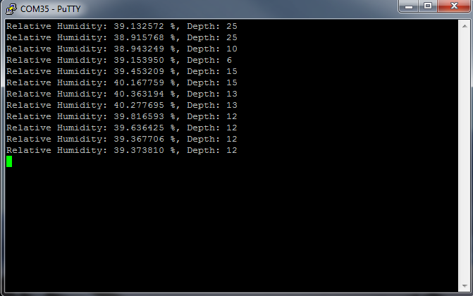

# Tutorial 5: Using Timers and the Real Time Clock

## Introduction

Until now, we have not been very efficient. We have been taking sensor readings and then pausing, using the CyDelay() function, before taking another reading. This is a somewhat wasteful use of PSoC resources, as it blocks the main() loop from executing any other code while delaying. A better option would be set some sort of alarm, which would go off when it was time to take a new reading. While the alarm is ticking, we could then spend our time doing other things. We can accomplish this using the external real time clock (RTC) that is built into the NeoMote. We will set an alarm on this clock, which will trigger when a certain amount of time has expired. When triggered, the alarm will query the sensors and return to the main() code when finished, until the next trigger.

**New Requirements:** *Software* – Metronome NeoLib Library

## Creating a Project with New Build Settings

Once again, we will base this tutorial on the previous tutorial. Call the new project RTCExample. The external real time clock (RTC) is a component specifically integrated into the NeoMote hardware. As such, PSoC Creator must be told which communications protocol the RTC uses and to which pins it is connected. Luckily, all we have to do is set the pins, as Metronome Systems provides a full RTC application programming interface (API) and drag and drop PSoC component. The API also controls all of the board’s wireless features, but more on that later. First we have to configure PSoC Creator to know where to look for the libraries associated with this API.

* In the Workspace Explorer, right click your project and select **Build Settings**. Under the **ARM** **GCC 4.4.1**, select **Compiler**.

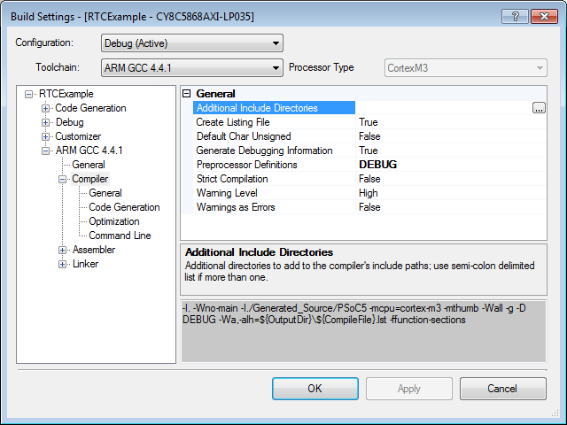

* Click on **Additional Include Directories**. Then click the  button that appears to the right. This will open a new window.
* Click **New**. Then click the  button and navigate to the **neolib** folder that was provided as part of the Metronome files. This tells the compiler where to look for the Metronome Systems libraries.

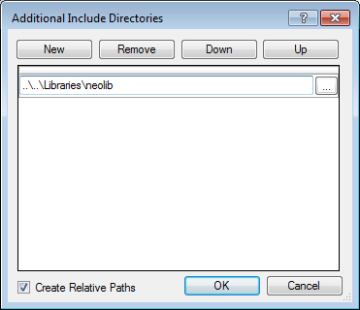

* Click OK.
* Without closing the main setting window, click on the **ARM** **GCC 4.4.1 -> Linker** item in the same list, and repeat the above process; click **Additional Library Directories**, and use the  button to add the **neolib** library. This tells the linker where to look for the Metronome Systems libraries.

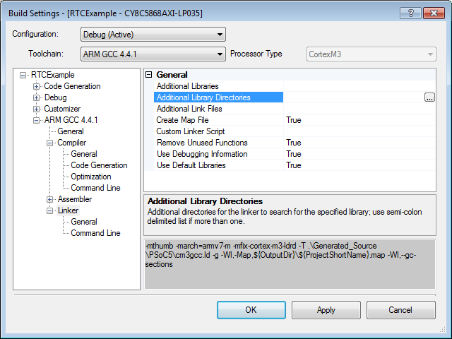

**Note:** Adding the neolib directory to the linker and compiler adds it to the list of files included when the mote gets programmed. This allows us to use the API’s designed by Metronome for the various features of the NeoMote. As development continues, this is where new features can be added.

* Under **Additional Libraries** do not browse, but simply type the name **neomote**. This will add the neomote library from the neolib directory.

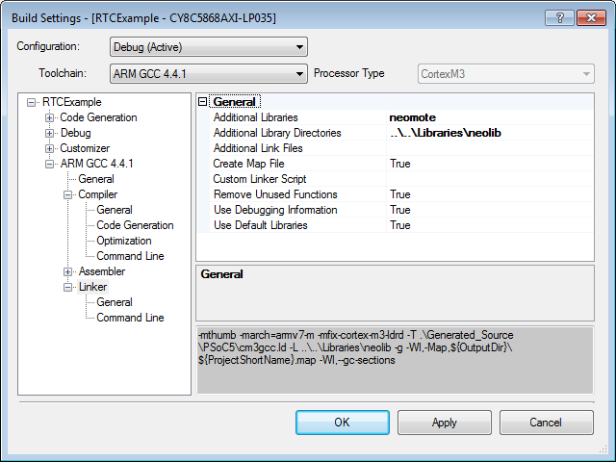

**Note:** At this point, you would be able to compile your code, but we still need to add the neo library to PSoC creator.

* Right click on your project again, and select **Dependencies**. Under **User Dependencies**, click the  button.

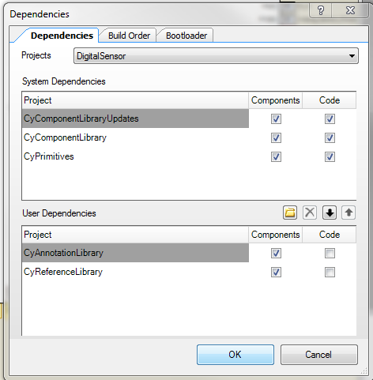

* Navigate to the **neolib** folder given to you by Metronome Systems. Inside this folder, open the **NeoMote.cylib** folder, and then select the **NeoMote.cyprj** file.

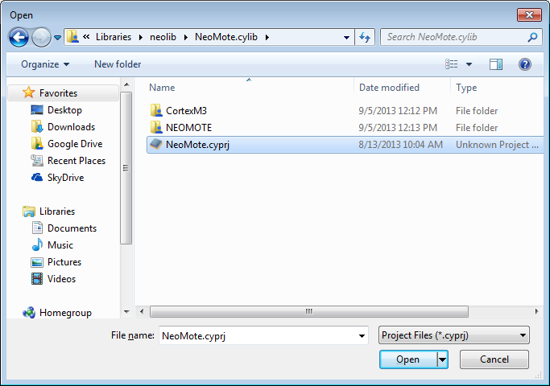

This will now allow you to use the NeoMote component in your schematics.

* Open your Schematic Window by clicking TopDesign.cysch.
* In the component Catalog, you will now see a new tab, called **Default**. Click this tab to reveal the **NEOMOTE** component and drag it to your schematic.

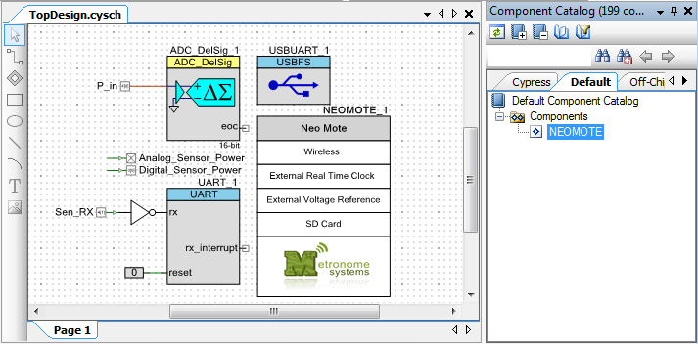

## Assigning Pins

Since the component controls all of the external peripherals, the NeoMote Component has a lot of pins. We don’t need to worry about what each pin does, but make sure the pin assignments match the following table.

|  |  |
| --- | --- |
| NeoMote Components | NeoMote Pins |
| \NEOMOTE_1:Rx_Pin\ | P2[1] |
| \NEOMOTE_1:RX_CTS_n\ | P2[2] |
| \NEOMOTE_1:External_VRef\ | P3[5] |
| \NEOMOTE_1:I2C_0_SCL\ | P12[4] |
| \NEOMOTE_1:I2C_0_SDA\ | P12[5] |
| \NEOMOTE_1:NEO_RTC_INT1\ | P1[6] |
| \NEOMOTE_1:RX_CTS_n\ | P2[2] |
| \NEOMOTE_1:RX_Pin\ | P2[1] |
| \NEOMOTE_1:RX_RTS_n\ | P2[3] |
| \NEOMOTE_1:SD_Card_Power\ | P2[0] |
| \NEOMOTE_1:TimeN\ | P2[7] |
| \NEOMOTE_1:TX_CTS_n\ | P2[5] |
| \NEOMOTE_1:TX_Pin\ | P2[4] |
| \NEOMOTE_1:TX_RTS_n\ | P2[6] |

**Note:** If your Neomote pins are incorrect, you will encounter a variety of errors in this tutorial and the next. Check twice.

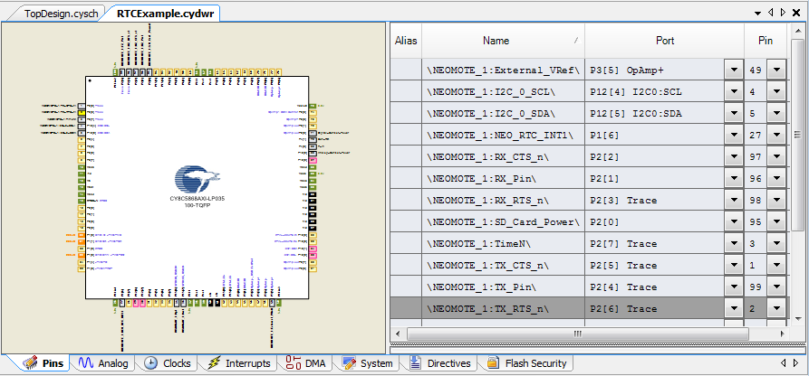

## Adding Code

Before we can build the code, we will need to add the neomote.h file to your project. This will make the API function calls for the NeoMote accessible in our main.c file once we include it.

* Right click the **Header Files** folder in your Workspace Explorer, and selecting **Add -> Existing Item**.

**Note:** You may have to change the file type in the Project Files dropdown to be able to see .h files. This means you added the file as a source file rather than a header file. This will still work.

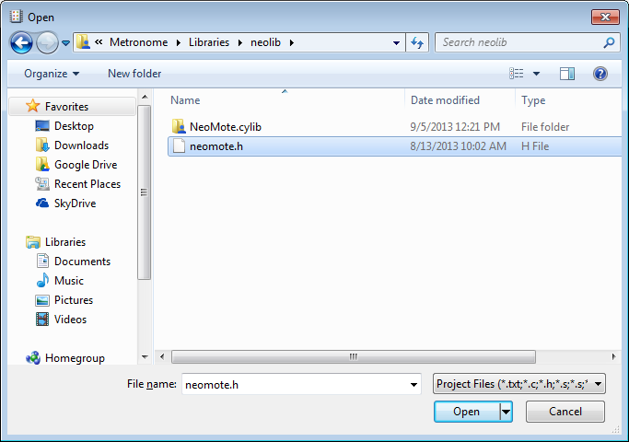

Next edit the code in the **main.c** file to reflect the following bolded changes below.

**Note:** Do not change the functions from the previous chapter that are used to read from the sensors. Though we will no longer use them in the main for loop, they will be used by the Event Handler we create.

#include <project.h>

#include <stdio.h>

#include <stdlib.h>

#include "USBUART_1.h"

#include "ADC_DelSig_1.h"

#include “UART_1.h”

#**include "neomote.h"**

float Take_RH_Reading(); // Function Prototypes.

uint8 Take_Depth_Reading();

**void rtcCallBackReceived(uint8 alarmType);**

int main(){

CYGlobalIntEnable;

USBUART_1_Start(0, USBUART_1_5V_OPERATION); // Initialize and start the UART.

while(!USBUART_1_bGetConfiguration());

USBUART_1_CDC_Init();

ADC_DelSig_1_Start(); // Initialize and start the ADC.

ADC_DelSig_1_StartConvert();

UART_1_Start(); // Start the UART.

**NeoRTC_Start(rtcCallBackReceived);** // Start and enable the RTC.

**NeoRTC_Set_Repeating_Minute_Alarm(1u);**

**NeoRTC_Enable_Second_Interrupt();**

for(;;){

Neo**RTC_Process_Tasks();**

}

}

float Take_RH_Reading(){…} // No changes here…

uint8 Take_Depth_Reading(){…} // No changes here…

**void rtcCallBackReceived(uint8 alarmType){ // RTC Event Handler.**

**if(alarmType == RTC_SECOND_ALARM){**

**NeoRtcTimeStruct tm_neo = NeoRTC_Read_Time();**

**char sendBuffer [64];**

**sprintf(sendBuffer, "%d:%d:%d %d/%d/%d\n\r", tm_neo.hour, tm_neo.minute,**

**tm_neo.second, tm_neo.day, tm_neo.month, tm_neo.year);**

**USBUART_1_PutString(sendBuffer);**

**}else if(alarmType == RTC_MINUTE_ALARM){**

**float RH = Take_RH_Reading();**

**uint8 depth = Take_Depth_Reading();**

**char sendBuffer [64];**

**sprintf(sendBuffer, "Relative Humidity: %2.2f%%, Depth: %d\n\r", RH, depth);**

**USBUART_1_PutString(sendBuffer);**

**}**

**}**

## Code Explanation

This code is definitely more involving that anything we’ve used up until now, but it should be relatively easy to understand. Notice that the code begins by calling the NeoRTC_Start() function. As its parameter the function take a callback which must be defined. When an alarm fires on the NeoMote RTC, the NeoMote will call your callback function and specify why it called it by providing you with an alarm Type parameter. For this to work, you need to declare a callback. We do this by creating our own rtcCallBackReceived() function. After starting the RTC, we then call the alarm setting function: NeoRTC_Set_Repeating_Minute_Alarm(). As a parameter, this function takes a duration in minutes for the alarm. By putting in a 1, we are telling the function to fire an alarm every minute. We also call the NeoRTC_Enable_Second_Interupt() function, which will fire an alarm every second. Inside our for loop, we have now stripped all of the code, except NeoRTC_Process_Task() function, which will only do something if the RTC requires it. Otherwise, our for loop is free to execute without being blocked.

When the RTC calls our custom callback function we first check which alarm called it. If it’s the *second interrupt*, we read the time from the RTC using the NeoRTC_Read_Time() function and write it to the USB UART. If it’s a *minute interrupt*, we read from the sensors and write the readings to the USB UART as well. This will print the time to the USB port each second, and print the sensor readings once every minute. This code brings us closer to a data logging platform.

## Running the Code

Program the NeoMote and connect to it with putty. Watch the sensor readings stream in.

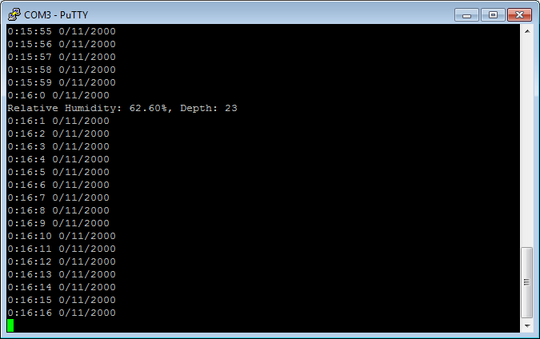

**Note:** You may notice the times that the clock prints to serial are completely invalid. Don’t worry; we will fix this later.

# Tutorial 6: Writing Data to the SD Card

## Introduction

While the NeoMote is equipped with very advanced wireless data transmission capabilities it is often also desirable to save data locally on the SD card interface. This could be useful in scenarios where single, non-networked nodes are deployed or non-essential mission data needs to be stored for post-processing. This tutorial will build upon the previous tutorial, but instead of printing the collected sensor readings to screen, we will now also save them to a text file on an SD card. This tutorial will bring you one step closer to developing a fully functional sensor data logger. Generate a new project called **SDCard**.

**New Requirements:** *Hardware* – SD Card *Software* – emFile Libraries

## Adding the emFile Libraries

Writing to an SD card is not as simple as it seems. For you to be able to read the files and folder on other PCs, you need to write your data in a standardized fashion. If you are familiar with file storage, you will know that, specifically, we’ll want to write the data using a file system. Luckily, PSoC has licensed an emFile system from another company. These steps will assume you are working with a FAT32 compatible SD card and have the emFile library from the Metronome kit.

**Note:** If you don’t have the libraries for the emFile, you can download them through the PSoC website. See the emFile datasheet for instructions on downloading this library.

**Note:** If your SD card is not set up with a FAT32 file system, see the **SD Card File System Setup**.

* Right-click the SDCard project in the workspace explorer and select **Build Settings**.
* Under **Arm GCC 4.4.1 -> Compiler**, use the  button to open **Additional Include Directories**.
* Add two **New** directories: **Code -> Include -> PSoC5** and **Code -> Include -> PSoC5 -> emf32nOS**

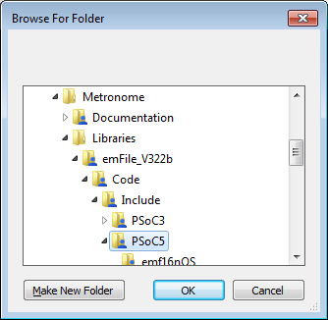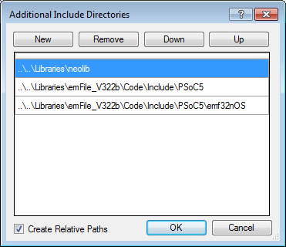

**Note:** You need to select the **nOS** version of these file systems to create it without an operating system. If your SD Card happens to be set up as a FAT 16 rather than 32, select **emf16nOS** folder instead of **emf32nOS**.

* Navigate to **ARM GCC 4.4.1 -> Linker**.
* Add the **Link Library -> PSoC5 -> GCC** subfolder from the emFile folder.

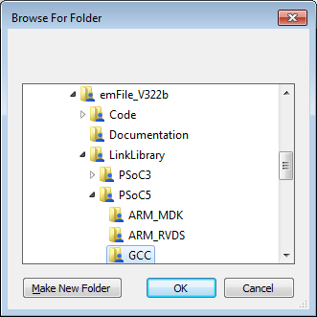

* Open the **Additional Libraries**, and **Add** a new entry called **emf32nosnlfn**.

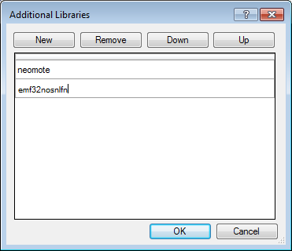

* Click OK and return to your project.

We are now able to use the emFile component to set up an SD Card.

## Adding the SD (emFile) Card Component

PSoC creator has a special component for writing to an SD card.

* In your schematic window, from **Communications -> File system**, drag and drop the **emFile SPI Mode** component.

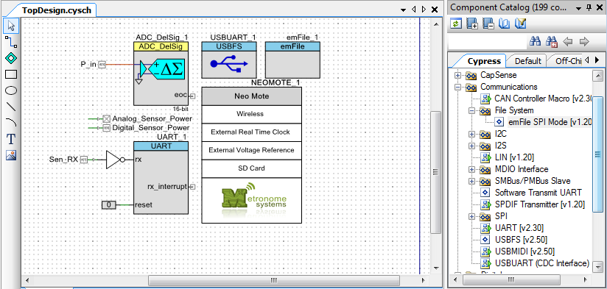

## Assigning Pins

In your pin assignment window, assign the emFile pints to reflect the following:

|  |  |
| --- | --- |
| SD Card Components | NeoMote Pins |
| \emFile_1:miso0\ | P6[3] |
| \emFile_1:mosi0\ | P6[1] |
| \emFile_1:sclk0\ | P6[2] |
| \emFile_1:SPI0_CP\ | P6[0] |

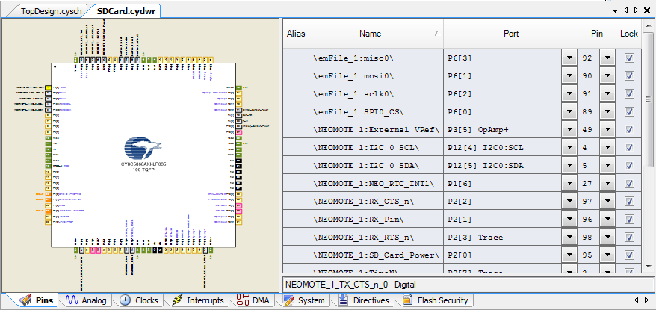

## Adding Code

* Define, and add the following function to your main.c file.

void Write_To_SD_Card(const char * fileName, const char * pMode,

const void * pData, U32 NumBytes){

NEOMOTE_1_SD_Card_Power_Write(0u); // Power on SD Card

FS_FILE * pFile;

char sdVolName[10]; // Buffer that will hold SD card volume name.

if(0 != FS_GetVolumeName(0, &sdVolName[0], 9)){

pFile = FS_FOpen(fileName, pMode);

if (pFile == 0){ // If the SD card doesn't open.

FS_DeInit();

FS_Init();

pFile = FS_FOpen(fileName, pMode);

}

FS_Write(pFile, pData, NumBytes);

FS_FClose(pFile);

}

NEOMOTE_1_SD_Card_Power_Write(1u); // Power off SD Card.

}

**Note:** Make sure you have prototyped this new function above your main with the other prototypes.

* Edit your rtcCallBackReceived() function to simply add the bolded line to write your sensor data to the SD card:

void rtcCallBackReceived(uint8 alarmType){ // RTC Event Handler.

if(alarmType == RTC_SECOND_ALARM){

NeoRtcTimeStruct tm_neo = NeoRTC_Read_Time();

char sendBuffer [64];

sprintf (sendBuffer, "%d:%d:%d %d/%d/%d\n\r", tm_neo.hour, tm_neo.minute, tm_neo.second, tm_neo.day, tm_neo.month, tm_neo.year);

USBUART_1_PutString(sendBuffer);

}else if(alarmType == RTC_MINUTE_ALARM){

float RH = Take_RH_Reading();

uint8 depth = Take_Depth_Reading();

char sendBuffer [64];

sprintf (sendBuffer, "Relative Humidity: %f %%, Depth: %d\r\n", RH, depth);

USBUART_1_PutString(sendBuffer);

**Write_To_SD_Card("myData.txt","a",sendBuffer,strlen(sendBuffer));**

}

}

* Add the file system header file by adding the following line to the top of your main.c file
* Add the start function for the emFile file system to the rest of your initialization code.

#include <stdio.h>

#include <stdlib.h>

**#include <FS.h>**

#include "USBUART_1.h"

#include "ADC_DelSig_1.h"

#include "neomote.h"

float Take_RH_Reading(); // Function Prototypes.

uint8 Take_Depth_Reading();

void rtcCallBackReceived(uint8 alarmType);

**void Write_To_SD_Card(const char * fileName, const char * pMode, const void * pData, U32 NumBytes);**

int main()

{

CYGlobalIntEnable;

USBUART_1_Start(0, USBUART_1_5V_OPERATION); // Initialize and start the UART.

while(!USBUART_1_bGetConfiguration());

USBUART_1_CDC_Init();

ADC_DelSig_1_Start(); // Initialize and start the ADC.

ADC_DelSig_1_StartConvert();

UART_1_Start(); // Start the UART.

NeoRTC_Start(rtcCallBackReceived); // Start and enable the RTC.

NeoRTC_Set_Repeating_Minute_Alarm(1u);.

NeoRTC_Enble_Second_Interrupt();

**FS_Init(); // Start the File System.**

## Running the Code

Program the NeoMote and open Putty. Every minute a sensor reading is printed to screen and will also be written to the SD card. Check your SD card to make sure your data is being written.

# Tutorial 7: Sending Wireless Data

## Introduction

This tutorial will send wireless data packets from the NeoMote to a Dust Networks manager. The hardest seeming task of wireless communication will actually be the easiest. The way Dust Networks and Metronome work together allows for a simple connection that is enabled by default.

**New Requirements:** *Hardware* – Dust Networks Manager

## Creating a Project

Create a new copy of your existing project and call it **Wireless**. This time, everything is already configured – all we have to do it add some code.

## Adding Code

As with the RTC component, the way we communicate with the wireless radio is by providing the NeoMote API with a callback function. The Radio will call your function when an event occurs.

* At the top of your **main.c** file, define your prototype callback:

void moteNotificationReceived(NeoMoteNotification notification);

* Define your separate callback function below the rest of your functions.

void moteNotificationReceived(NeoMoteNotification notification){

if(notification.type == TYPE_MOTE_EVENT){

uint8 type = notification.payload[0];

if(type == EVENT_MOTE_OPERATIONAL){

USBUART_1_PutString("Mote Joined Network and ready.\n\r");

}

}else if(notification.type == TYPE_MOTE_DATA){

USBUART_1_PutString("Mote received packet.\n\r");

}

}

* Start your Wireless radio by adding its start() function to the rest of your initializations.
* Add the Mote_Process_Tasks() call to your for loop.

**Mote_Start(moteNotificationReceived);**

for(;;)

{

**Mote_Process_Tasks();**

NeoRTC_Process_Tasks();

}

* Add a command sending your data to the manager at the same time you save it to file.

USBUART_1_PutString(sendBuffer);

**Mote_Send_Packet((uint8*)sendBuffer,strlen(sendBuffer));**

Write_To_SD_Card("myData.txt","a",sendBuffer,strlen(sendBuffer));

**Note:** The buffer you send with the Mote_Send_Packet command must be cast to a uint8* because that is the input it takes.

## Running the Code

All that remains is to build and program your code. The next step requires you to have your NeoMote in a network with a Dust Networks Manager. If you have already set up a network, you simply need to open the API Explorer and subscribe to all notifications to see your incoming packets.

**Note:** If you have not already set up your Manager, see **AN-3 Setting Up a NeoMote SmartMesh IP Network**.

# Tutorial 8: Low-Power Mode

## Introduction

This tutorial will set the mote to sleep between performing functions so as to save power when mote utilities are unneeded. Each component will be put to sleep and then awoken each time the mote must complete a sensor reading or data transmission.

**New Requirements:** *None.*

## Creating a Project

Create a copy of Wireless and rename it **LowPowerMode**. This project will use a timer to keep track of low-power sleep but as a result cannot use the USB communication UART used previously.

* Drag the SleepTimer component onto the schematic (it defaults to come with an isr)
* Delete your USBUART_1 component.

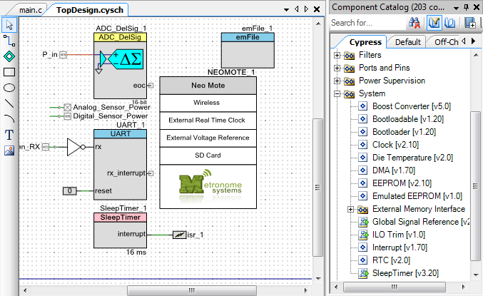

* Add Output Enables to each of your Sensor Power pins.

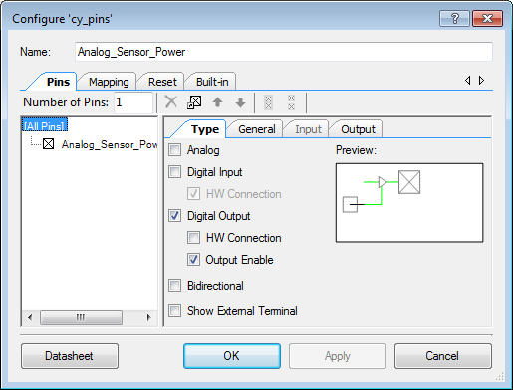

* Connect a Control Register to the enables.

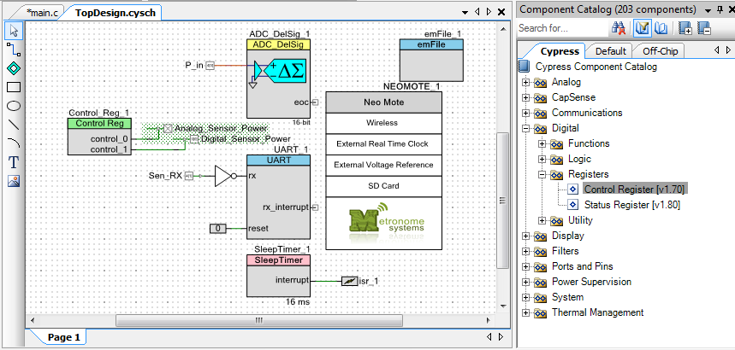

**Note:** If you have used any additional Sensor Power pins, you will need to connect all of them to Control Registers, up to eight per register.

## Adding Code

The code modifications for this project are a bit more complex than before mostly due to the fact that in order to utilize Low-Power Sleep mode, we must discontinue our use of the USBUART we used to connect to the computer’s serial terminal. This is not an issue as its main purpose was simply debugging. Therefore, we will go through the code step by step and make the appropriate changes.

* In your list of include statements, add and remove the following for access to SleepTimer’s API.

REMOVE:

#include "USBUART_1.h"

ADD:

#include "SleepTimer_1.h"

* In your list of function prototypes, add the following prototypes so we can define them later.

ADD:

void Goto_Low_Power_Mode();

void Components_Sleep();

void Components_Wakeup();

CY_ISR_PROTO(WakeupIsr);

* In the main() function, add and remove the following snippets.

REMOVE:

USBUART_1_Start(0, USBUART_1_5V_OPERATION);

while(!USBUART_1_bGetConfiguration());

USBUART_1_CDC_Init();

ADD:

SleepTimer_1_SetInterval(SleepTimer_1__CTW_4_MS);

Control_Reg_1_Write(255);

CHANGE THE *FOR* LOOP:

for(;;){

if( ! Mote_Process_Tasks()){

if( ! NeoRTC_Process_Tasks()){

Go_To_Low_Power_Mode();

}

}

}

* Choose a method to remove references to USBUART from the function rtcCallBackReceived.

The simplest method is to just remove the two lines - USBUART_1_PutString(sendBuffer);

This however leaves the sendBuffer string created but unused. As an alternative you can do something else with this data, such as send a packet or save to write it to the SD card. The third option is to simply remove the SecondAlarm and all reference to it. Eliminating the need to do anything with the excess time data. This third option is explored below. Simply rewrite the rtcCallBackReceived function as follows and remove the SecondAlarm enable line.

void rtcCallBackReceived(uint8 alarmType){

if(alarmType == RTC_MINUTE_ALARM){

float RH = Take_RH_Reading();

uint8 depth = Take_Depth_Reading();

char sendBuffer [64];

sprintf(sendBuffer, "Relative Humidity: %2.2f%%,Depth: %d\n\r", RH, depth);

Mote_Send_Packet((uint8*)sendBuffer,strlen(sendBuffer));

Write_To_SD_Card("myData.txt","a",sendBuffer,strlen(sendBuffer));

}

}

REMOVE:

NeoRTC_Enable_Second_Interrupt();

* In the function moteNotificationReceived, we will need to remove or replace the two lines pertaining to the USBUART.

REMOVE:

USBUART_1_PutString("Mote Joined Network and ready.\n\r");

USBUART_1_PutString("Mote received packet.\n\r");

(OPTIONAL) REPLACE WITH RESPECTIVELY:

Write_To_SD_Card("myData.txt","a","Mote Joined Network and ready.\n\r",32);

Write_To_SD_Card("myData.txt","a","Mote received packet.\n\r",23);

Now we need to write the new functions that will allow us to enter sleep mode.

* Create the function void Goto_Low_Power_Mode().

void Goto_Low_Power_Mode(){

Components_Sleep();

CyPmSleep(PM_SLEEP_TIME_NONE, PM_SLEEP_SRC_CTW);

Components_Wakeup();

}

This function will put all your components to sleep to save their configurations, sleep until the previously specified timer triggers and then wake up and restore each of the components to allow continued operation.

The next step is to write the functions that put to sleep and wakeup all of your components.

* Create the functions void Components_Sleep() and void Components_Wakeup(), as well as the ISR that will actually do the awakening.

void Components_Sleep(){

ADC_DelSig_1_Sleep();

UART_1_Sleep();

emFile_1_Sleep();

NeoRTC_Sleep();

Mote_Sleep();

Control_Reg_1_Write(0u);

SleepTimer_1_Start();

isr_1_StartEx(WakeupIsr);

SleepTimer_1_EnableInt();

CyPmSaveClocks();

}

void Components_Wakeup(){

CyPmRestoreClocks();

SleepTimer_1_Stop();

isr_1_Stop();

Control_Reg_1_Write(255);

Mote_Wakeup();

NeoRTC_Wakeup();

emFile_1_Wakeup();

UART_1_Wakeup();

ADC_DelSig_1_Wakeup();

}

CY_ISR(WakeupIsr){

SleepTimer_1_GetStatus();

}

**Note:** If you have used any components outside those covered in the tutorial or any duplicates not added here, make sure you add a _Sleep() and _Wakeup() function for them. Most, if not all, components have these functions specifically for this purpose.

The CyPmSaveClocks and CyPmRestoreClocks functions protect the clock settings that we use for our project because to enter sleep mode, the clocks must be modified to a specific setup to maintain consistency.

## Code Explanation

We must remove the use of our USBUART because we cannot maintain a constant UART connection if we are cycling the power off and on. This is not a bad thing as we want to stray away from that connection and move towards completely wireless communication.

We change the main *for* loop to enter sleep mode if the two Process Task functions have no tasks to process.

The sleep functions we call in Components_Sleep and their paired wakeup functions in Components_Wakeup are simply to save all the settings and put to sleep each component you have used. Any component that needs to be initialized or started at the beginning needs to be put to sleep and woken up, including the Real Time Clock and Dust Mote. We then need to start the Sleep Timer, its respective isr and enable the interrupt. The final step is to save the system clocks so that the clock speeds can be changed for sleep mode.

## Running the Code

When running the code, you should first ensure that the wireless communication to the manager is unharmed. Simply open the APIExplorer as in the Wireless tutorial and ensure that your mote is joining the network. To ensure that the sleep mode is working and saving power you can check the power consumption of the entire mote.

# Tutorial 9: Wireless Datalogger

## Introduction

This tutorial will set allow us to receive data from a wireless sensor through the manager connected to our computer.

**New Requirements:** *None.*

## Creating a Project

Create a copy of LowPowerMode and rename it **WirelessDatalogger**. This project will be completely code oriented. We will not add any additional components or any code to the NeoMote.

## Adding Code

## Running the Code

# Chapter 3: Problem Solving

This section will go over problems you can have with your NeoMote setup and how to approach and solve these problems.

## Troubleshooting Failed Compiles

There are many ways a build or program can fail to compile using the PSoC Creator. This section will go over some of the basic errors you might see when attempting a compile, what they mean, and the best way to deal with them. The most important thing for this section is to know where to find you **Notice List/ Output** frame. This frame is usually located at the bottom of the PSoC window. It has two tabs, one that says Output and the other is the Notice List. All the errors accumulated during compile will show up in the Notice List so most of this section will look at interpreting its messages. The Output gives detailed information about the steps taken during the Build and Program processes and requires more in depth understanding of the PSoC Creator to decipher.

### Spelling Error

Let’s begin with one of the simplest errors. Imagine you see a list of errors like this in your Notice List after you try to build your program.

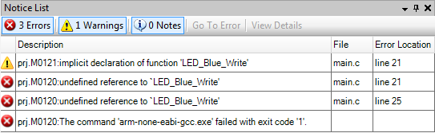

The first line in the Notice List is not an error, but a warning. When it describes something as an “implicit declaration” that usually means you have used something before actually declaring it, whether a function or a variable. The other two errors are two specific instances of using a function that doesn’t exist. “undefined reference” means the compiler doesn’t know what this function is or does. The first thing to check when you get one of these errors is the spelling. Is the function spelled the way it should be? In this example yes it is. So then you check the component it is referring to. In this case the error was giving the LED_Blue pin the wrong name. Because I spelled LED_Blue incorrectly in the Schematic, the API call that PSoC generates for that component had the wrong name and calling LED_Blue_Write() no longer worked.

### Missing Header File

This is another common error people run into. If you forget to include the header file that explains to the compiler how certain functions work, the compiler will not know what to do with them.

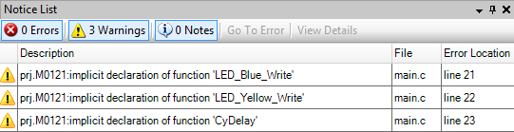

In this case I left out the line including the project.h file. The compiler then throws three warnings letting you know that this is the first time it has seen these functions because there is no header describing them. This problem can be simply fixed by including the appropriate header file, in this case:

#include <project.h>

### Missing Quotation Marks

When using functions like USBUART_PutString, always remember to put double quotes around any text you are sending that is not a variable.

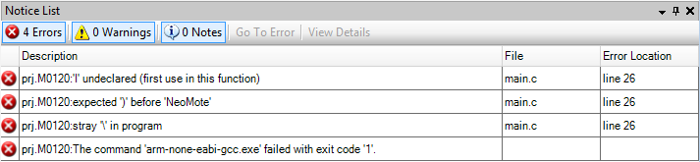

If all the errors are unclear and on the same line, it is likely you are missing quotation marks or parentheses.